# Lab Practical #01:

1. Study of various templates. E.g. Metronic, Unify, AdminLTE, etc.
2. Short note on the observation you made from the Metronic templates.

This is an adaptive and multifunction admin dashboard template, fitted with Twitter Bootstrap and AngularJS blocks. Metronic has a clear and user-friendly balanced design allowing you to make an attractive and easy-to-operate admin dashboard for website management.

1. Short note on the observation you made from the Unify templates.

|  |
| --- |
| if "unify template" refers to a specific software or framework, it would be helpful to know more details. In software development, frameworks often provide templates that developers can use as a foundation for building applications. A unified template in this context might imply a standardized starting point that promotes consistency and best practices in software development.  If you have a more specific context or if there's a particular area you're referring to, please provide additional details for a more accurate response. |

1. Short note on the observation you made from the AdminLTE templates.

|  |
| --- |
| AdminLTE is a free, open-source administration dashboard template built on top of The Bootstrap framework. Designed for web applications and content management systems, AdminLTE provides a sleek, responsive, and customizable user interface for managing and visualizing data. |

1. Installation of Figma on local machine and understanding the Figma software IDE

Steps of Installation:

|  |
| --- |
| Step 1: |
| Step 2: |

|  |
| --- |
| Step 3: |
| Step 4: |

# Lab Practical #02:

1. Develop 1 mobile and 1 web screen using the tools listed below:

Basic Tools: Position, Size, Rotation, Color Styles, Masks, Dark Mode with Selection Colors, Gradients, Creating Backgrounds.

1. 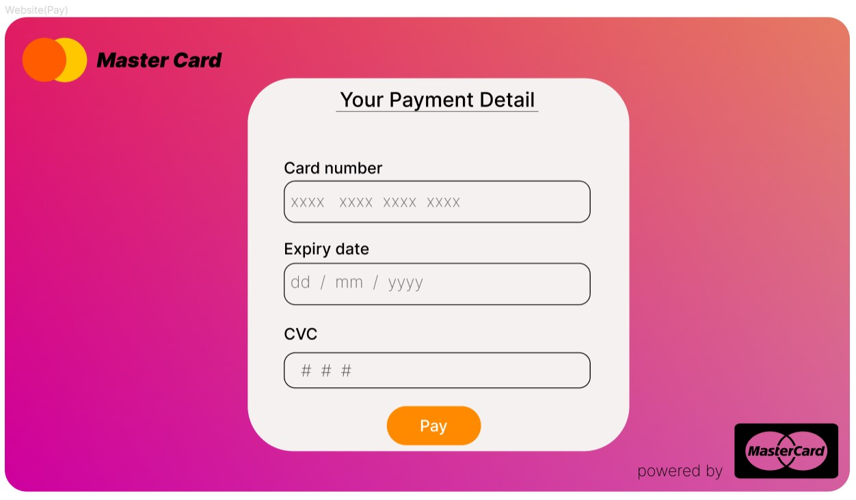Web Screen.

|  |
| --- |
|  |
|  |

1. 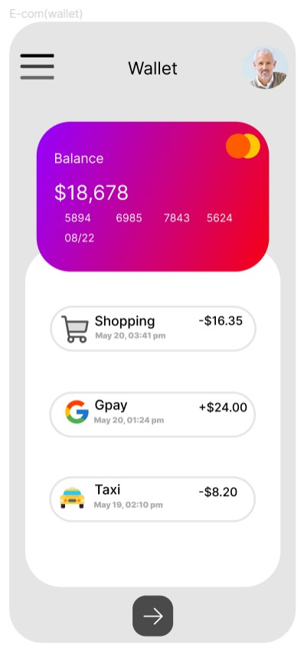Mobile Screen.

|  |
| --- |
|  |

# Lab Practical #03:

1. Develop 1 mobile and 1 web screen using the tools listed below:

Blending Modes, Alignment, & Distribution, Union and Corner Radius, Shadow, Blur Effects, Using Images, Fill, & Stroke, Text Properties & Styles.

* 1. Web Screen.

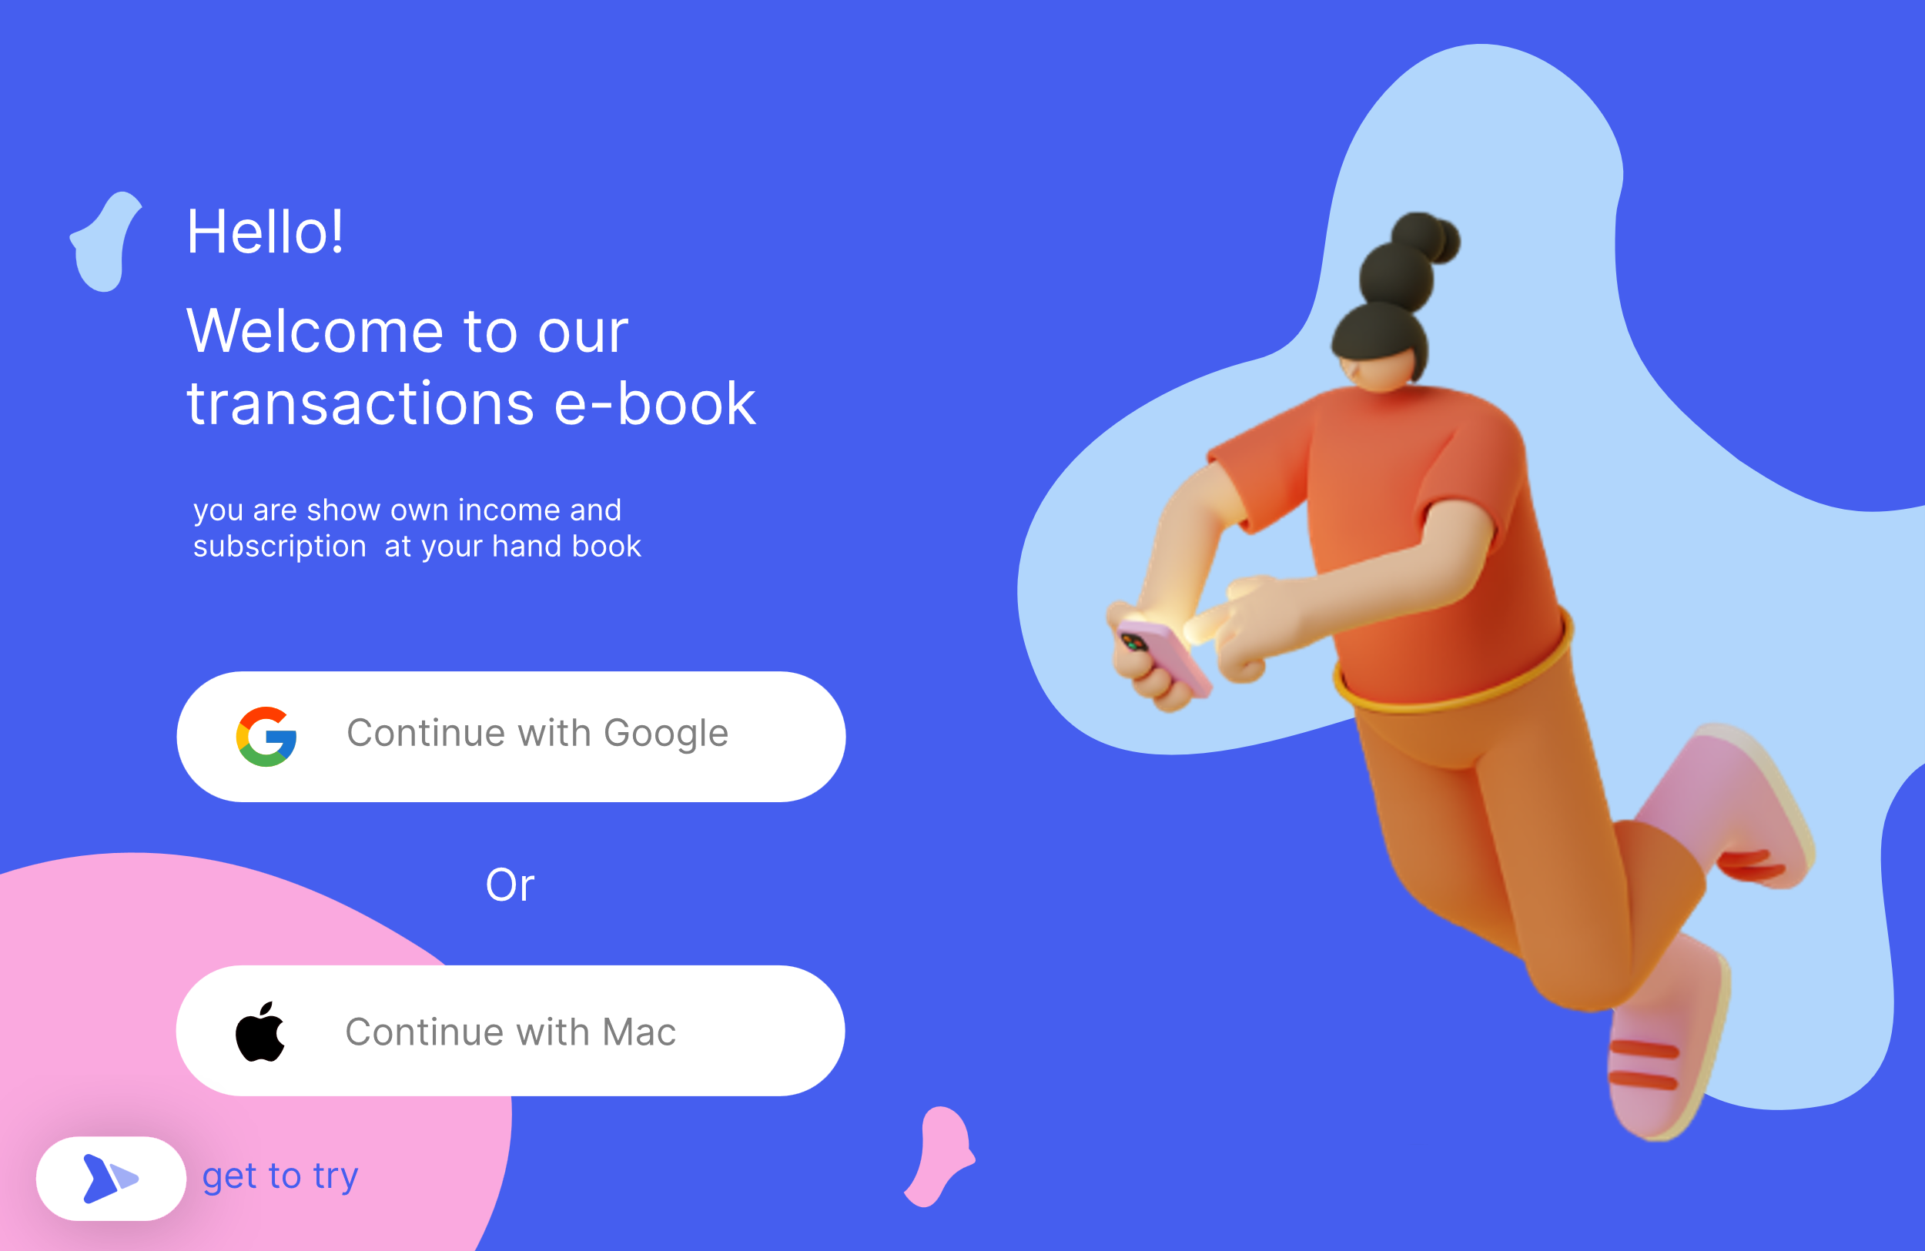

* 1. 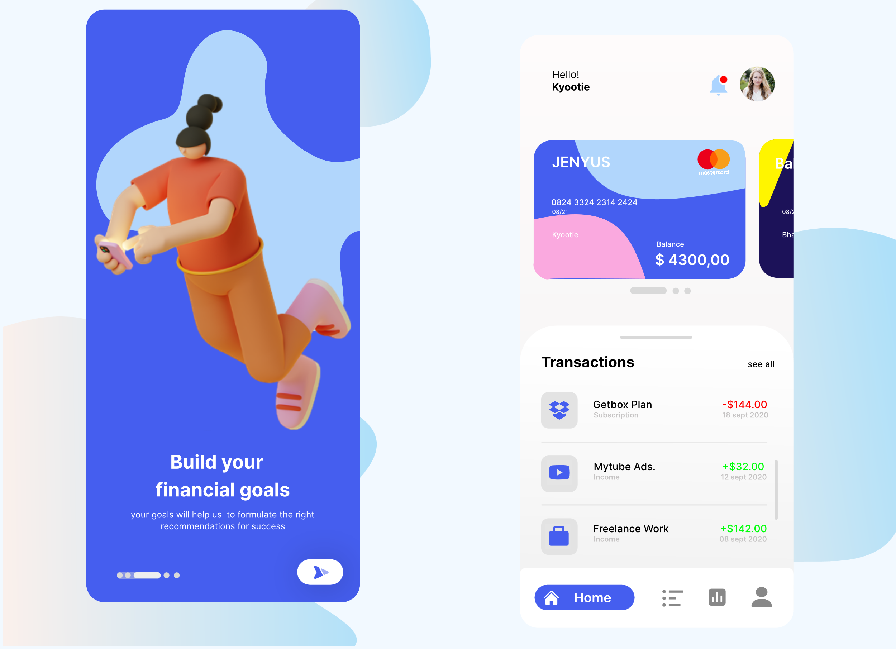Mobile Screen.

# Lab Practical #04:

1. Develop 1 mobile and 1 web screen using the tools listed below:

Google & Custom Fonts, Accessibility, Responsive Design, Constraints, Layout Grid, Auto Layout in Figma, Prototyping, Plugins in Figma.

1. 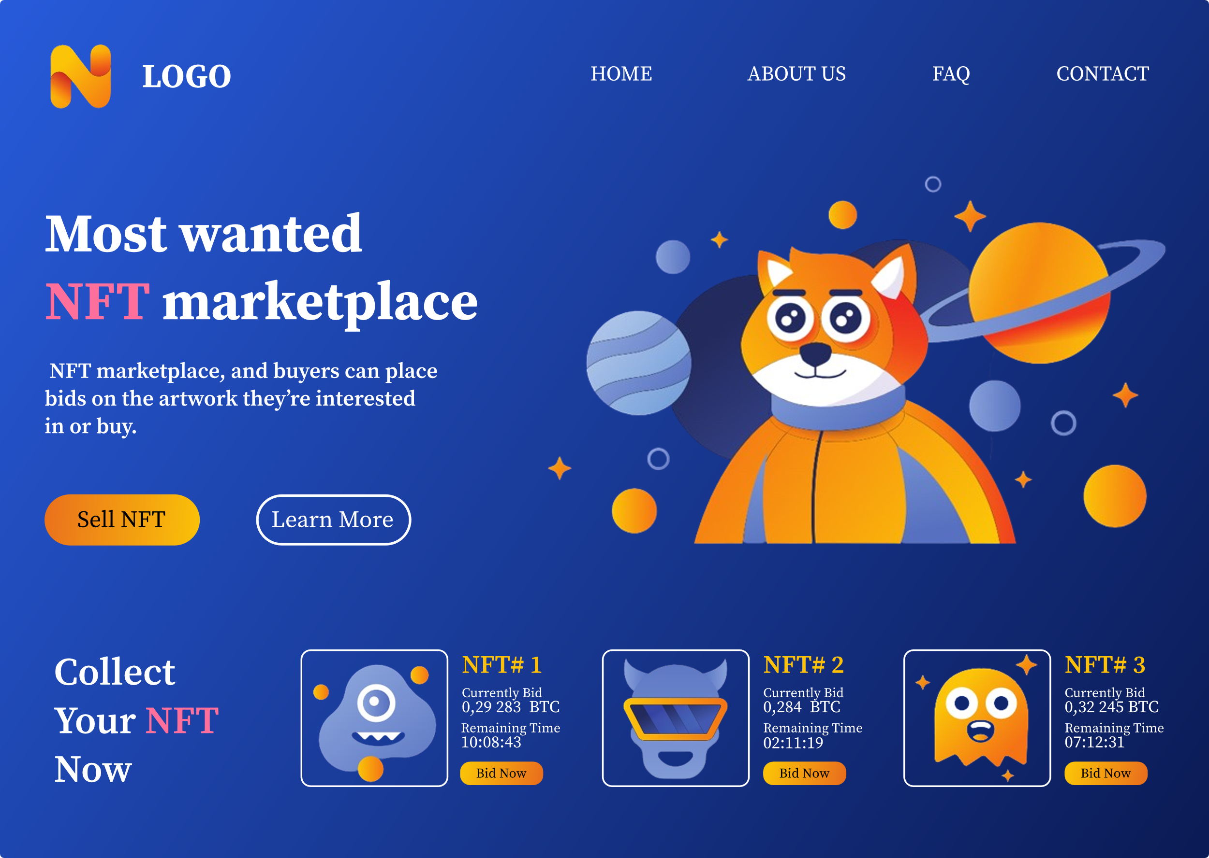Desktop screen
2. mobile screen

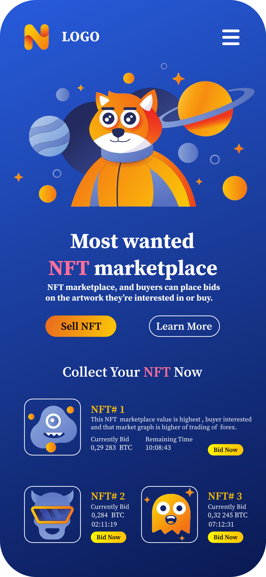

1. 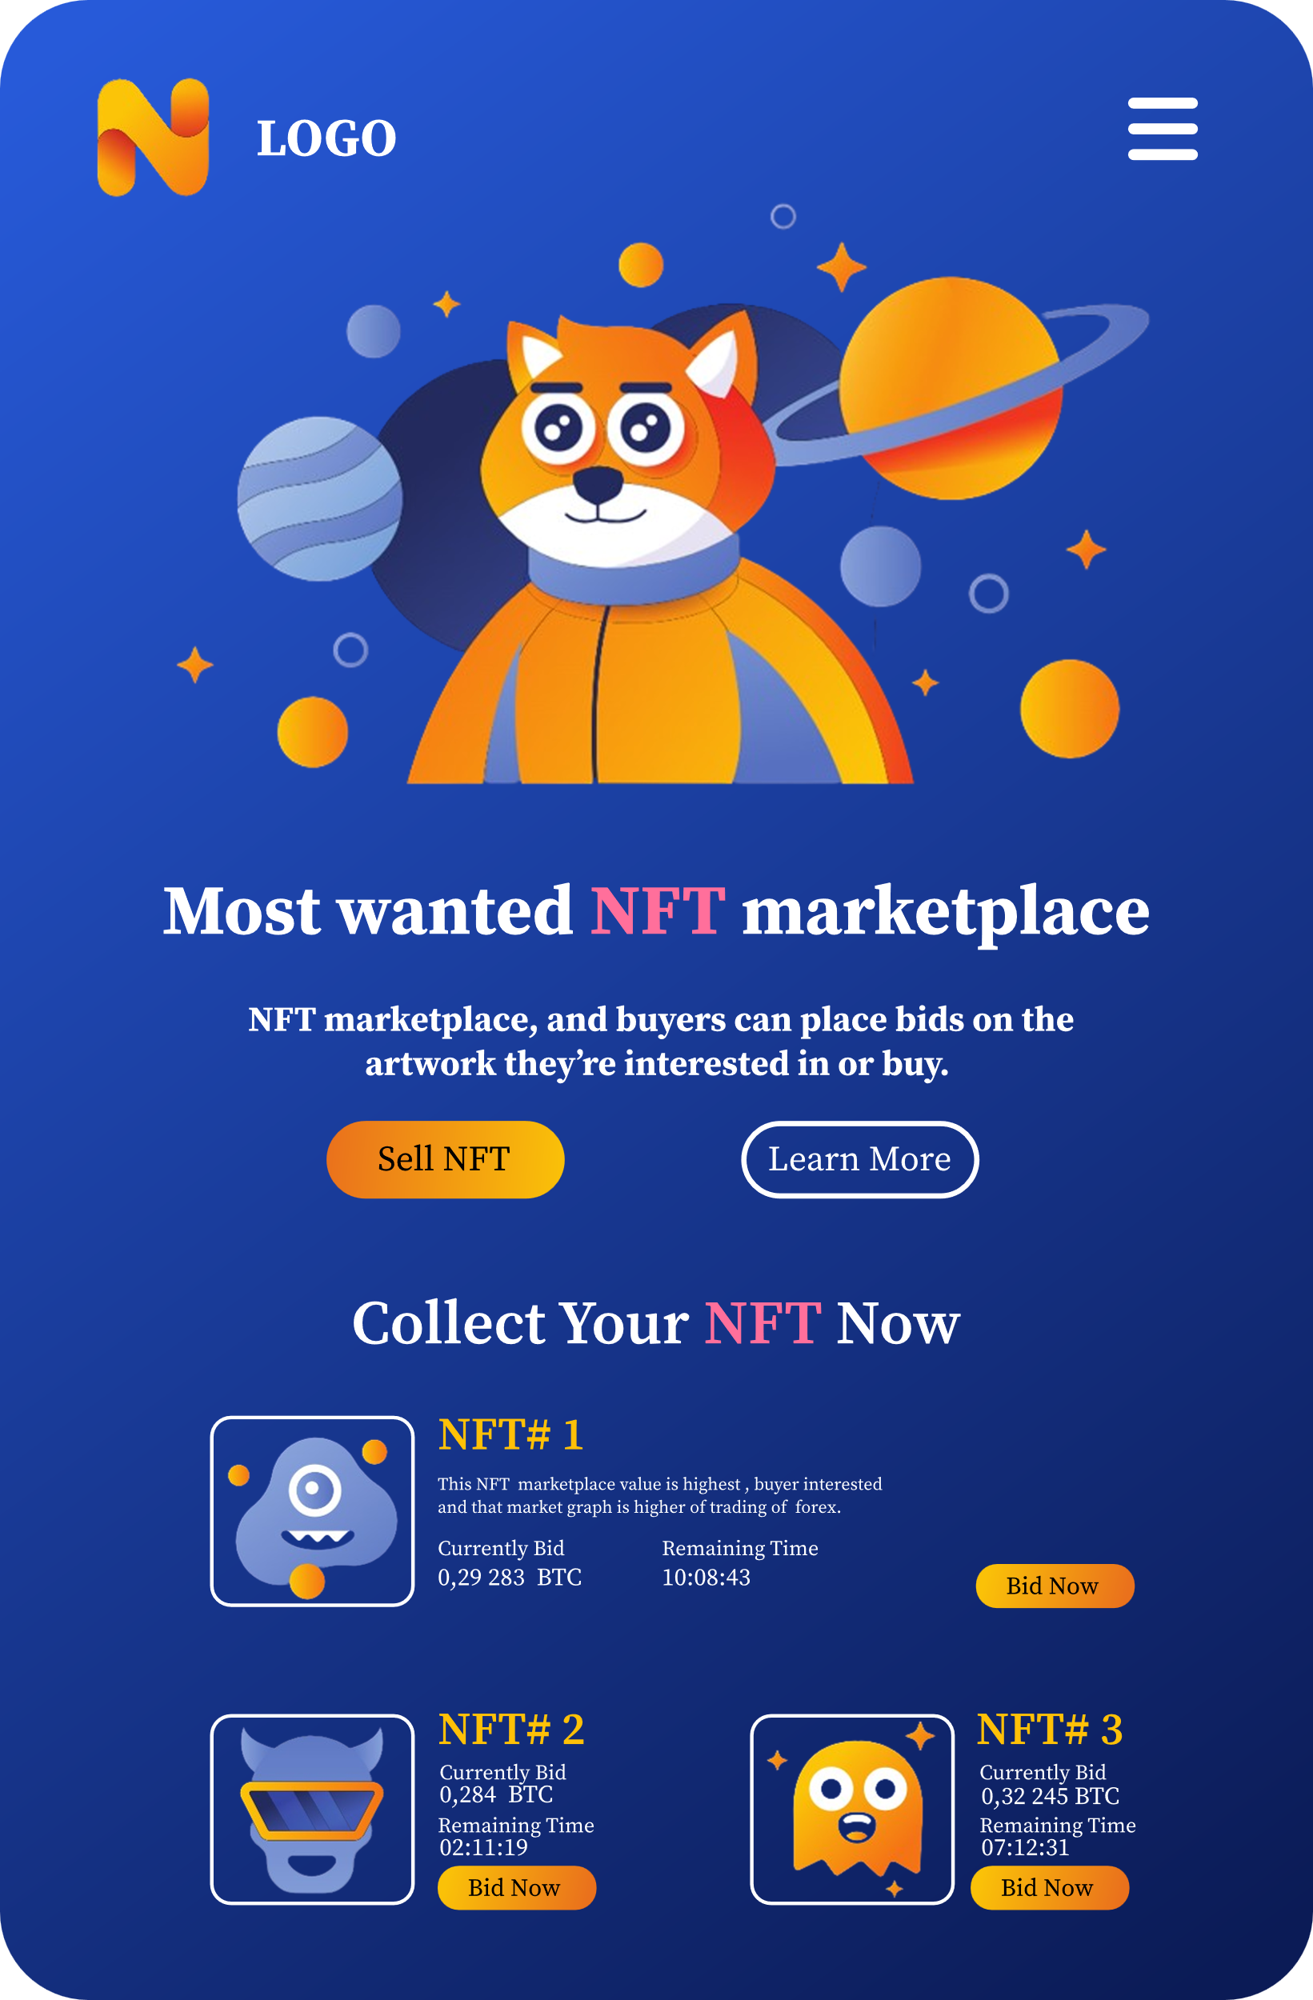tablet screen

Reference By FreePik.com:

* 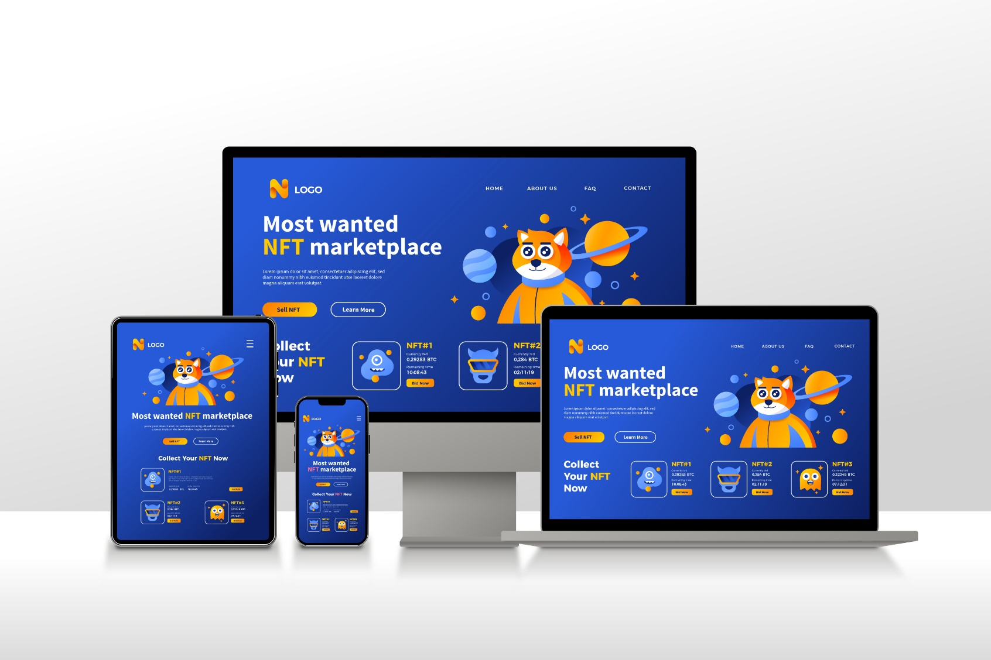<https://www.freepik.com/free-photos-vectors/responsive>
* **Use Google Font: Sans Serif-Pro**
* **Plugin Figma: Iconify**
* **Constraints: Center**

# Lab Practical #05:

1. Create login, registration/signup, forgot/reset password screen for your project.

* Project Name :- LIFE BANK (crowdfunding base)

1. Entrance Screen.
2. Onboarding Screen.
3. Login Screen.
4. Registration / Signup Screen.
5. Forgot / Reset Password Screen.
6. Entrance Screen.

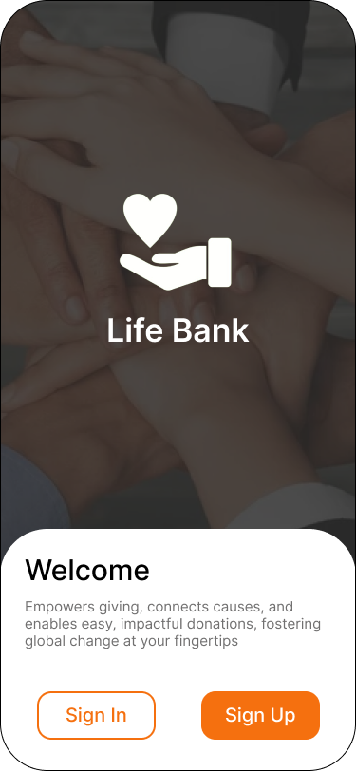

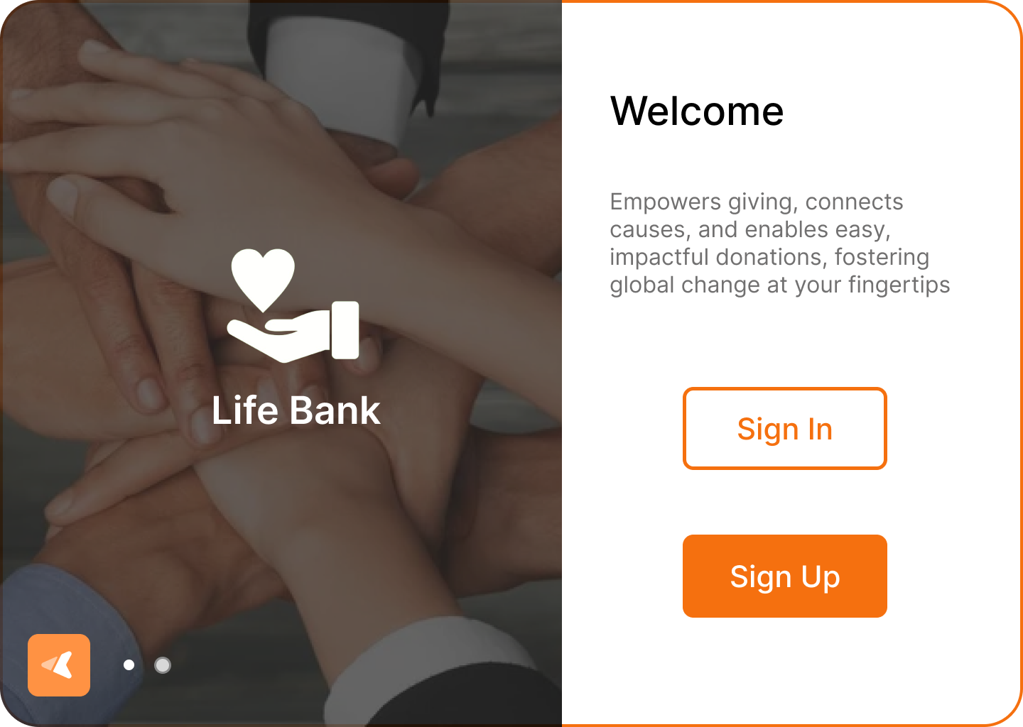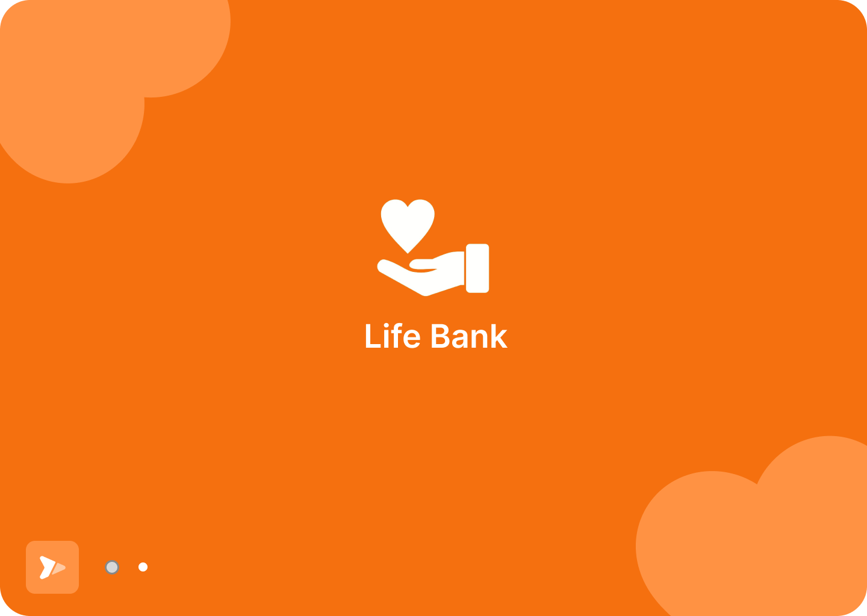

1. Onboarding Screen.

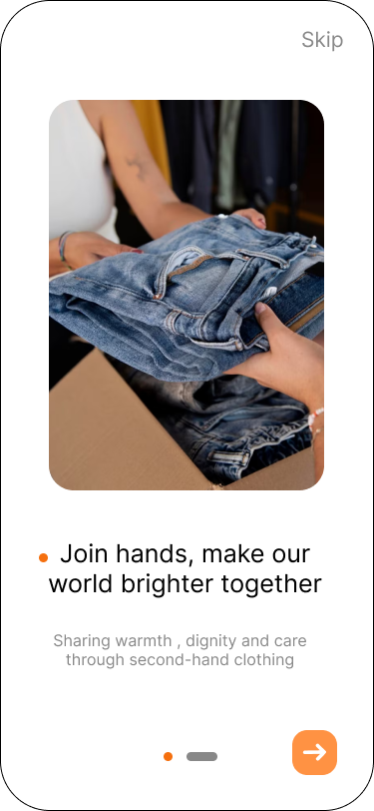

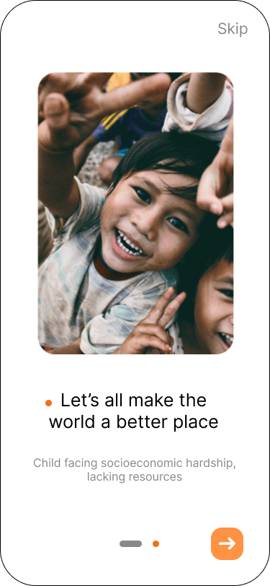

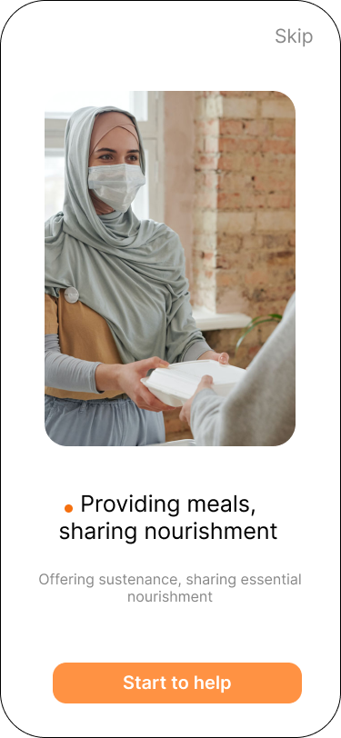

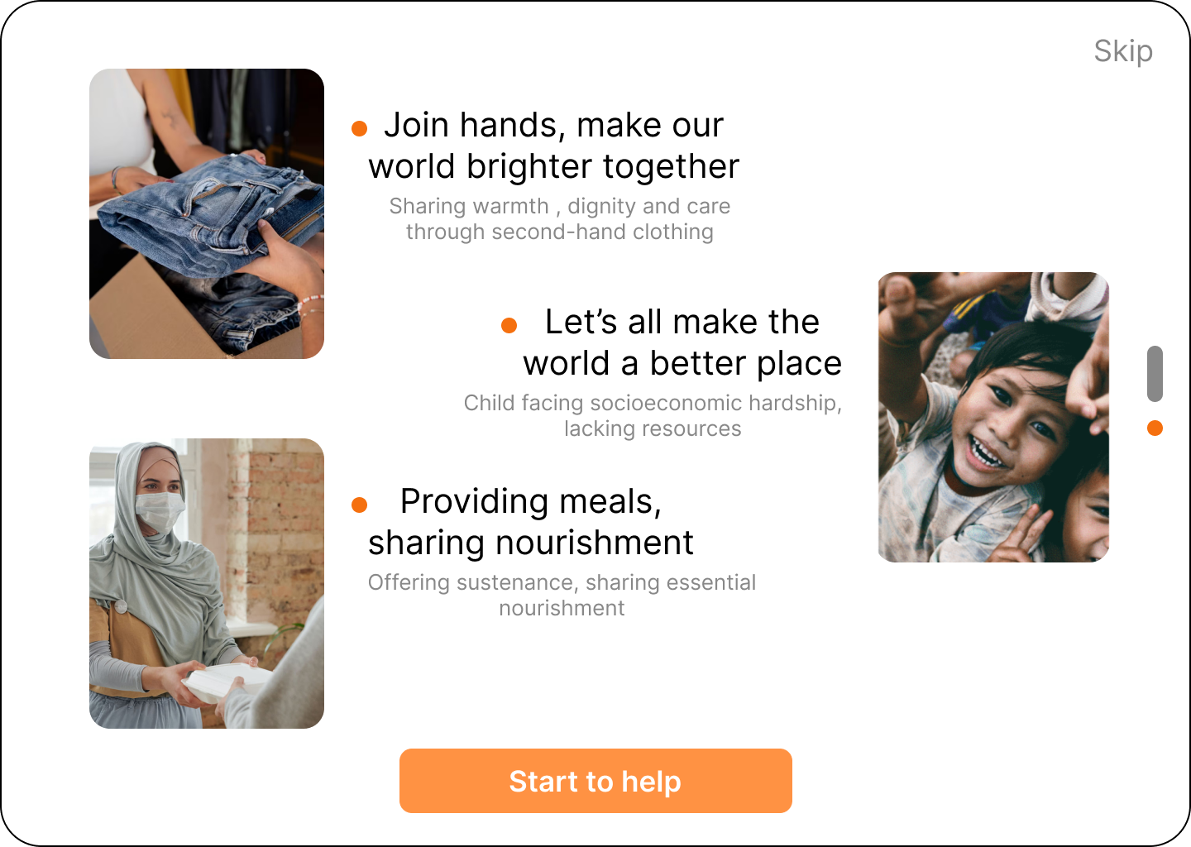

1. Login Screen.

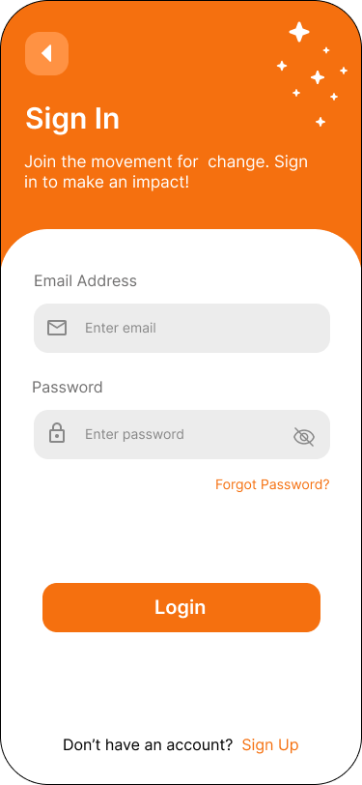

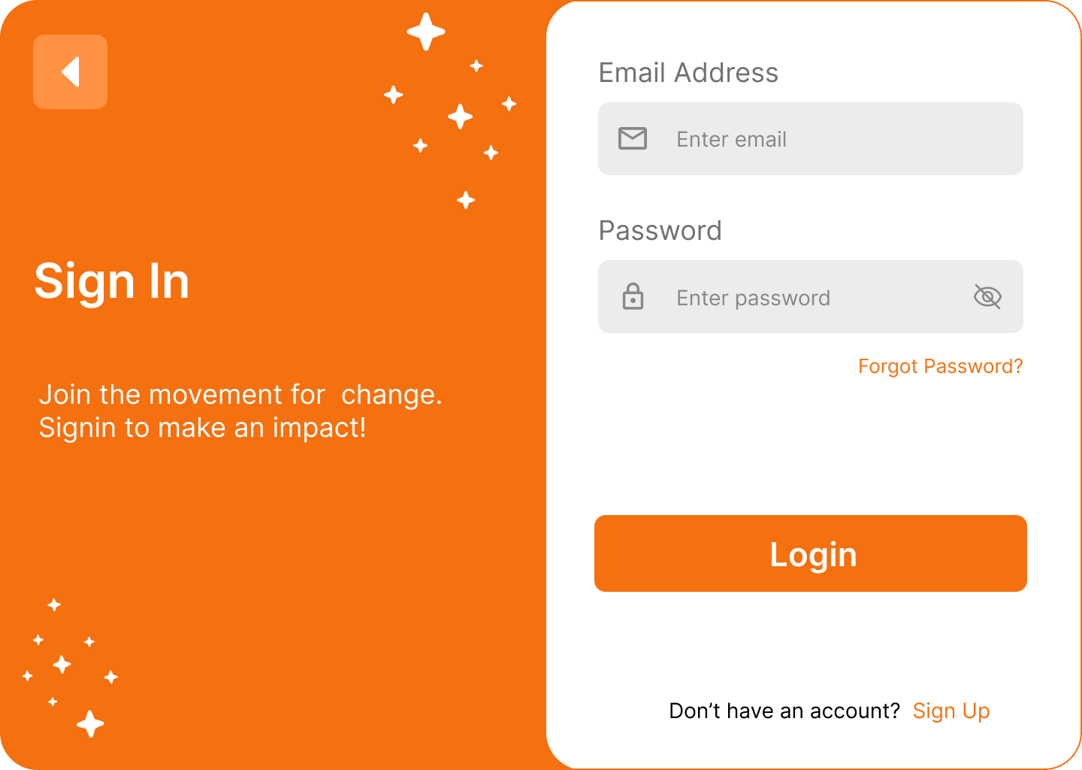

1. Registration / Signup Screen.

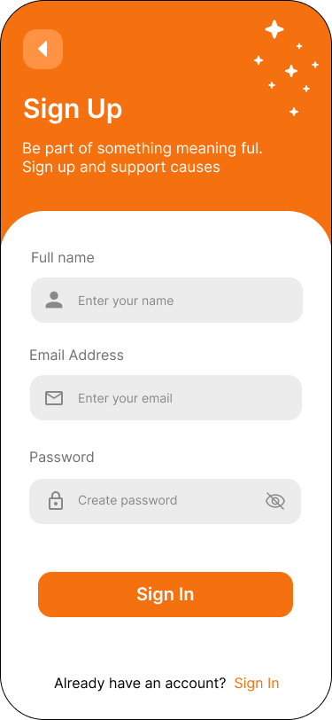

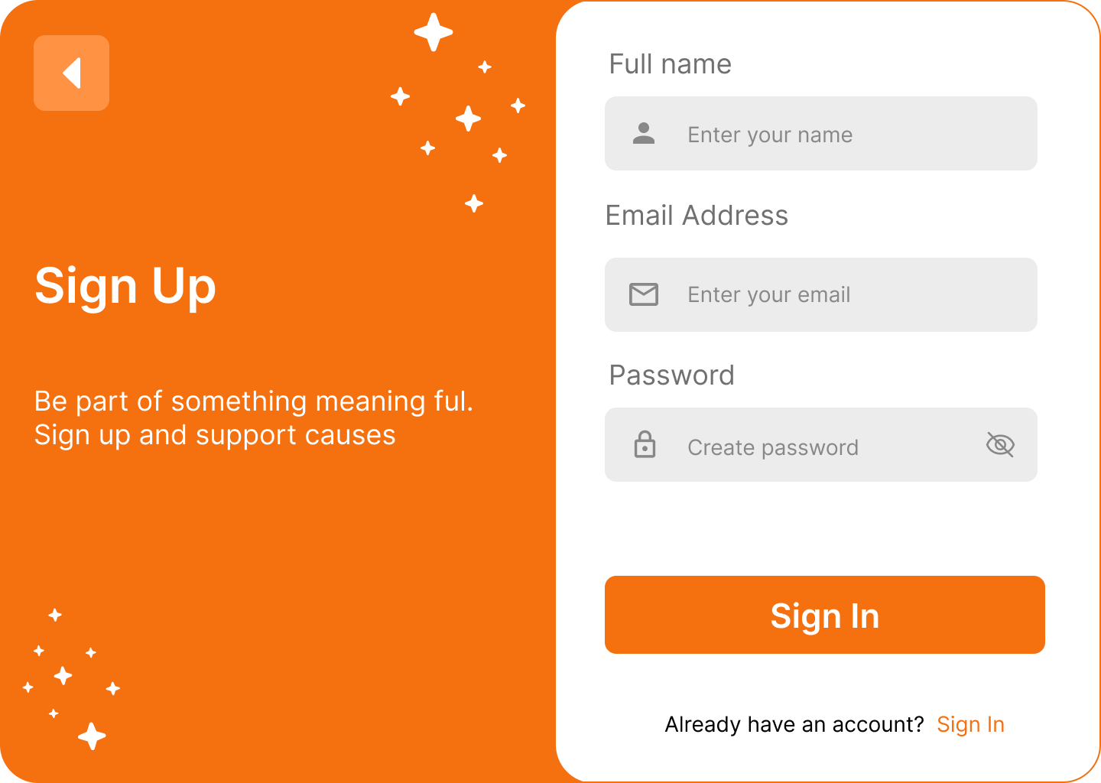

1. 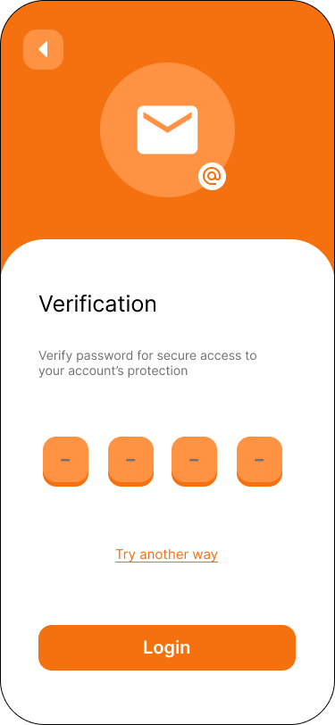Forgot / Reset Password Screen.

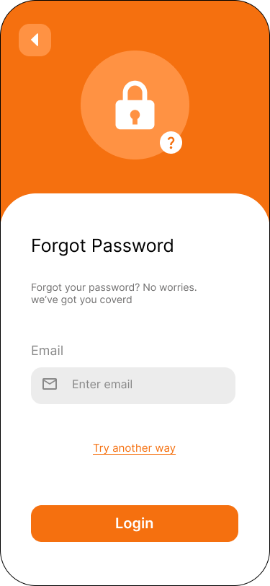

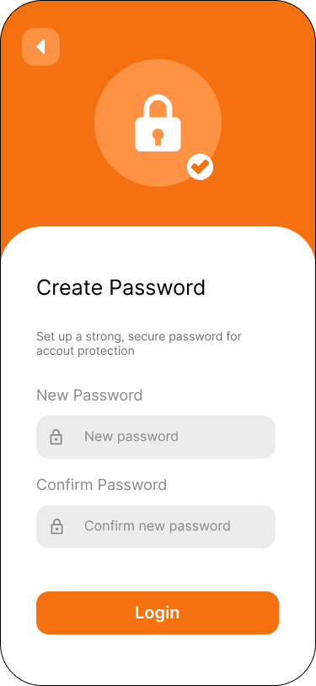

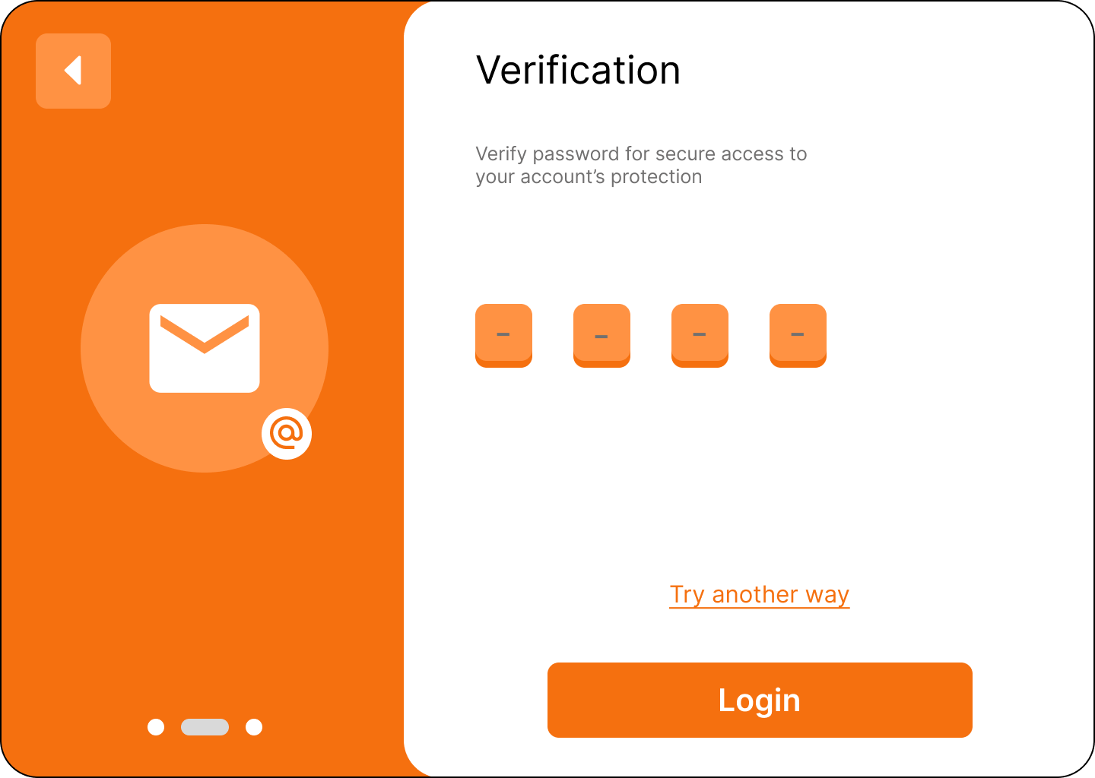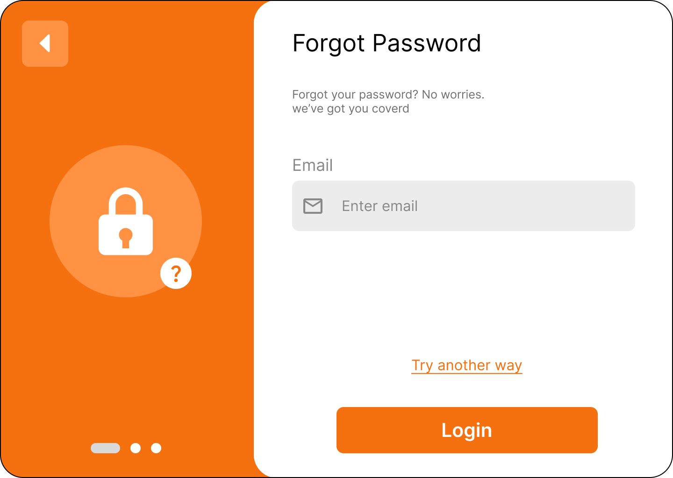

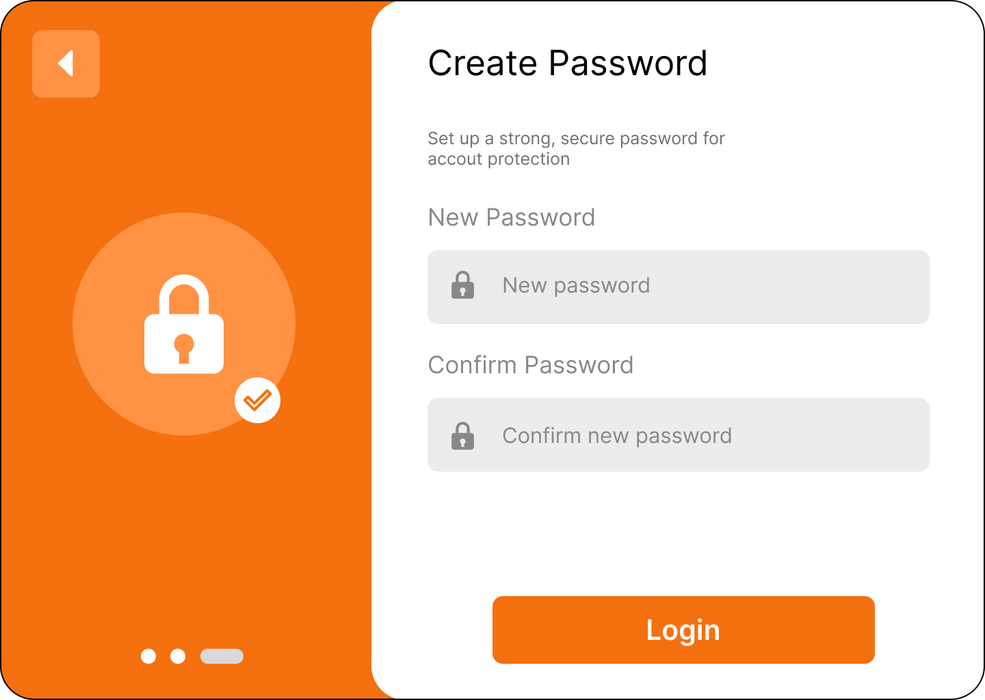

# Lab Practical #06:

1. Create dashboard for your project.
2. 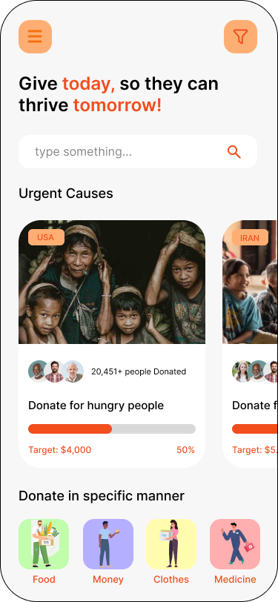Dashboard Screen.

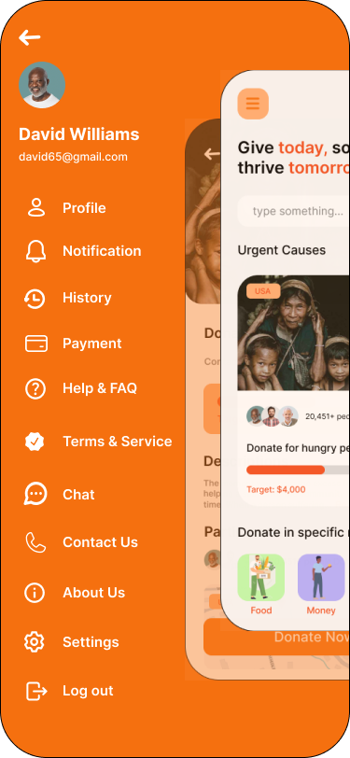

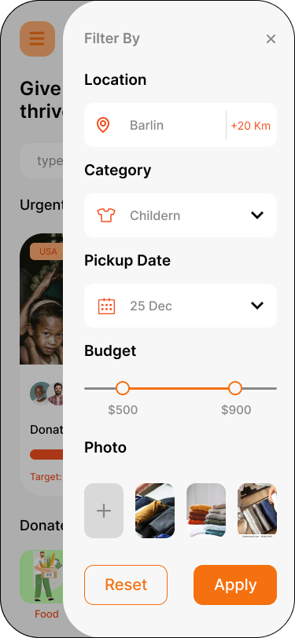

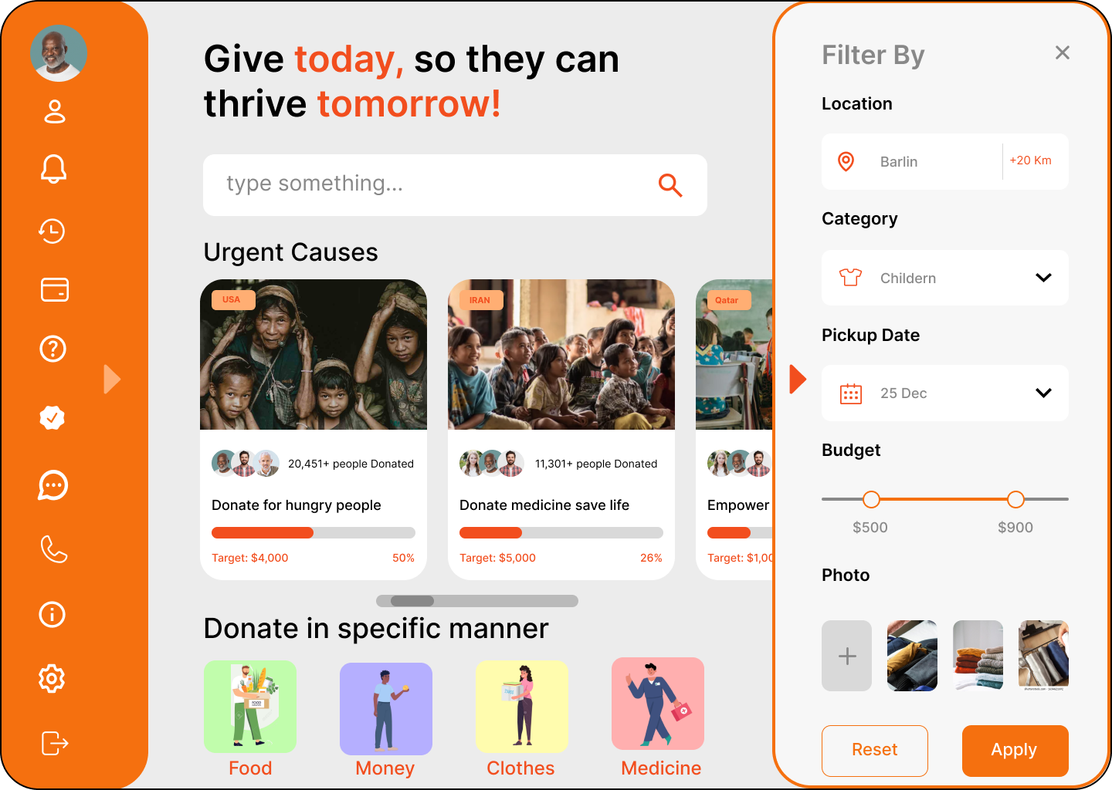

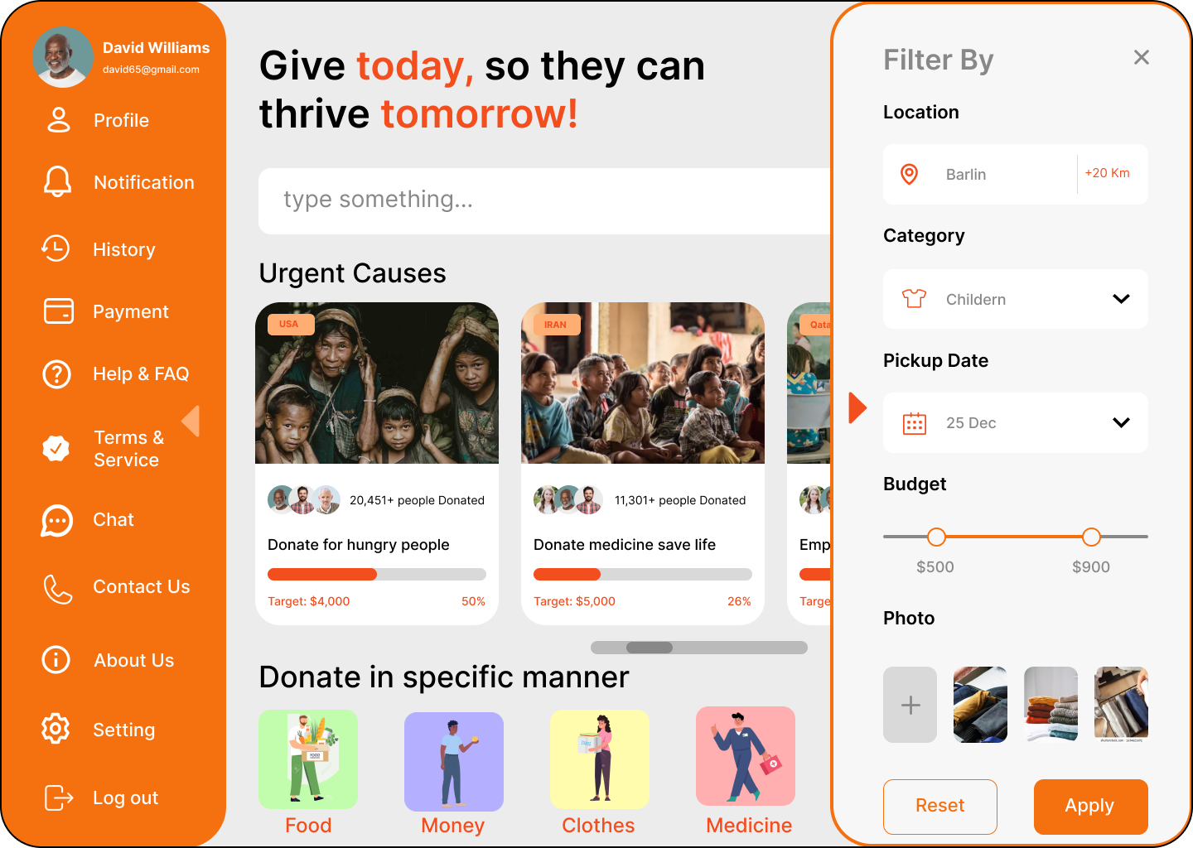

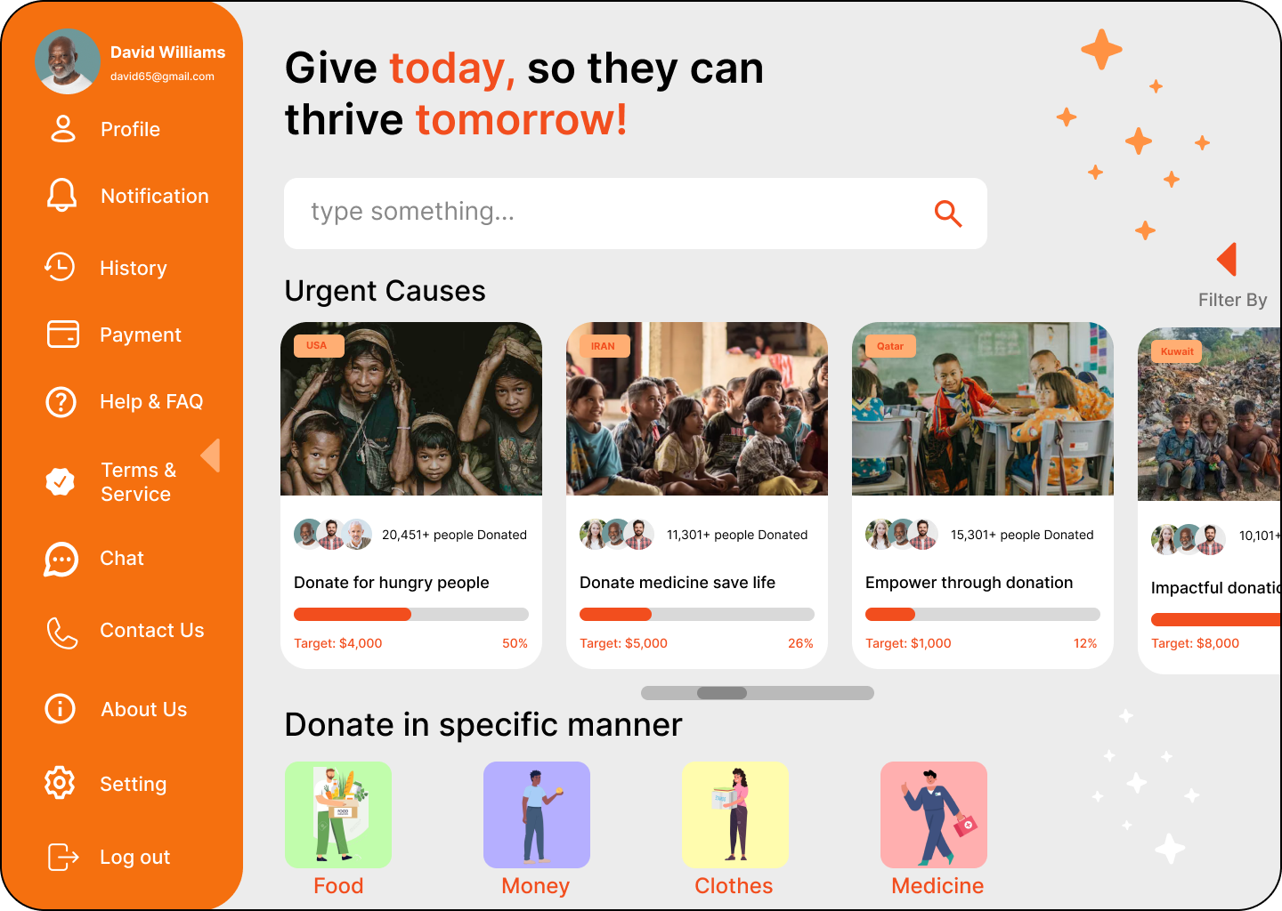

# Lab Practical #07:

1. Create screens to edit/view user profile – account information.
2. 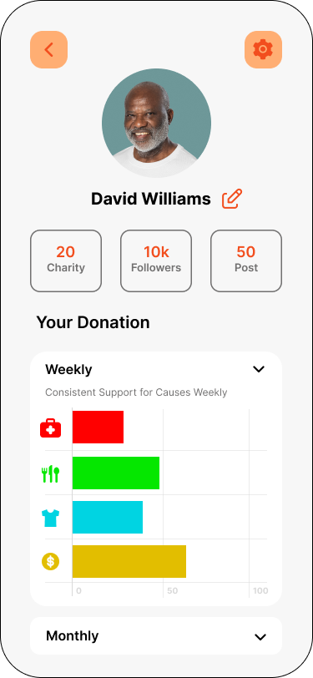View User Profile Screen.

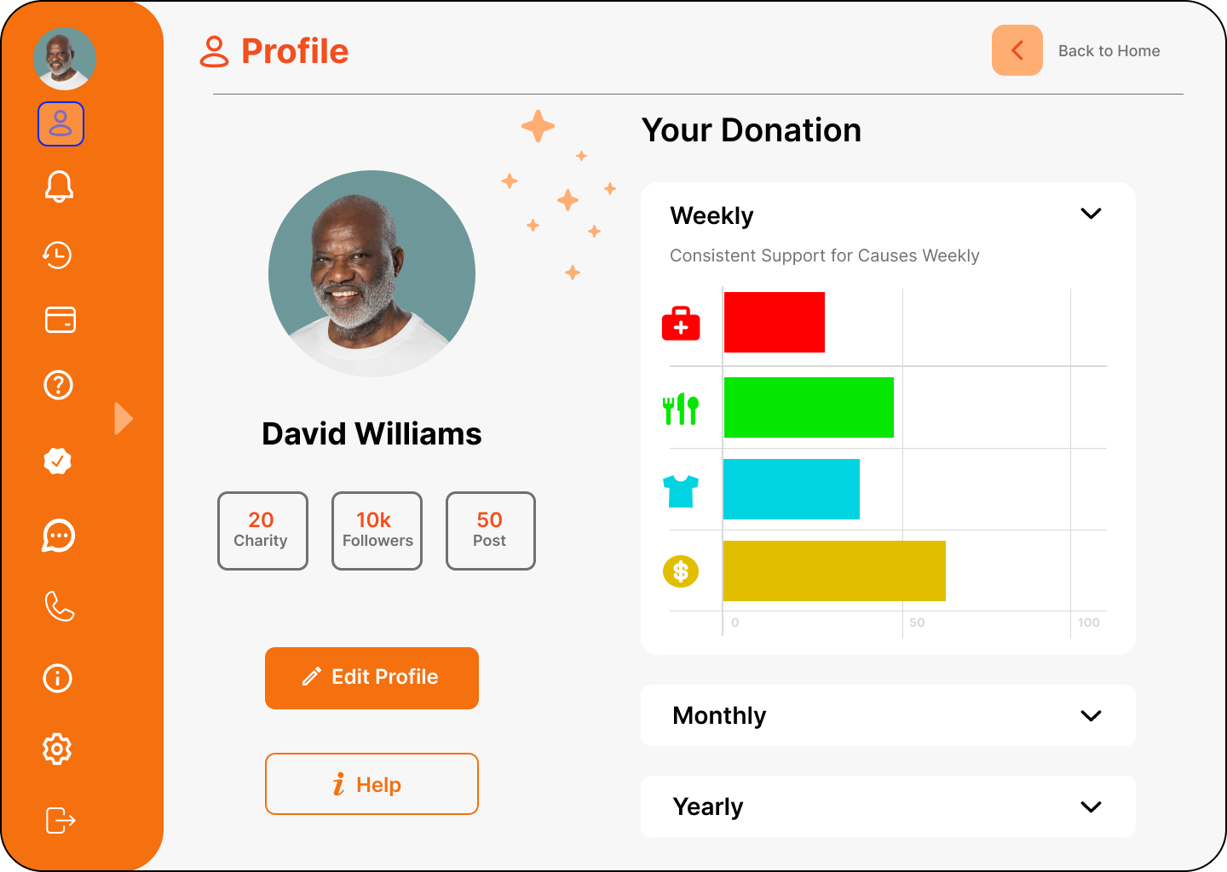

1. Edit User Profile Screen.

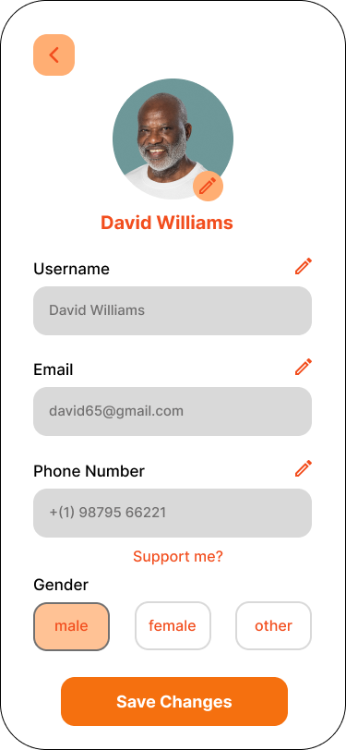

# Lab Practical #08:

1. 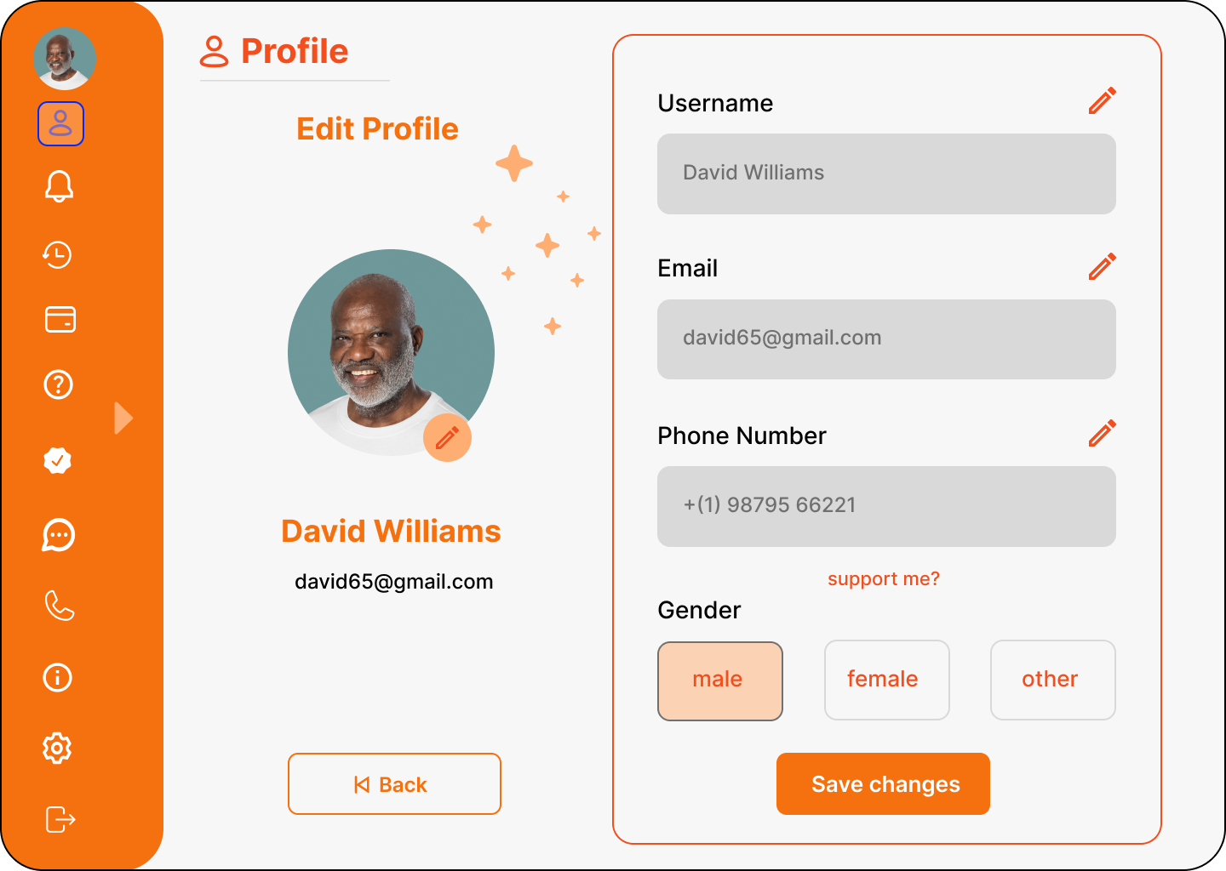Create screens to add/edit/view product information.
2. 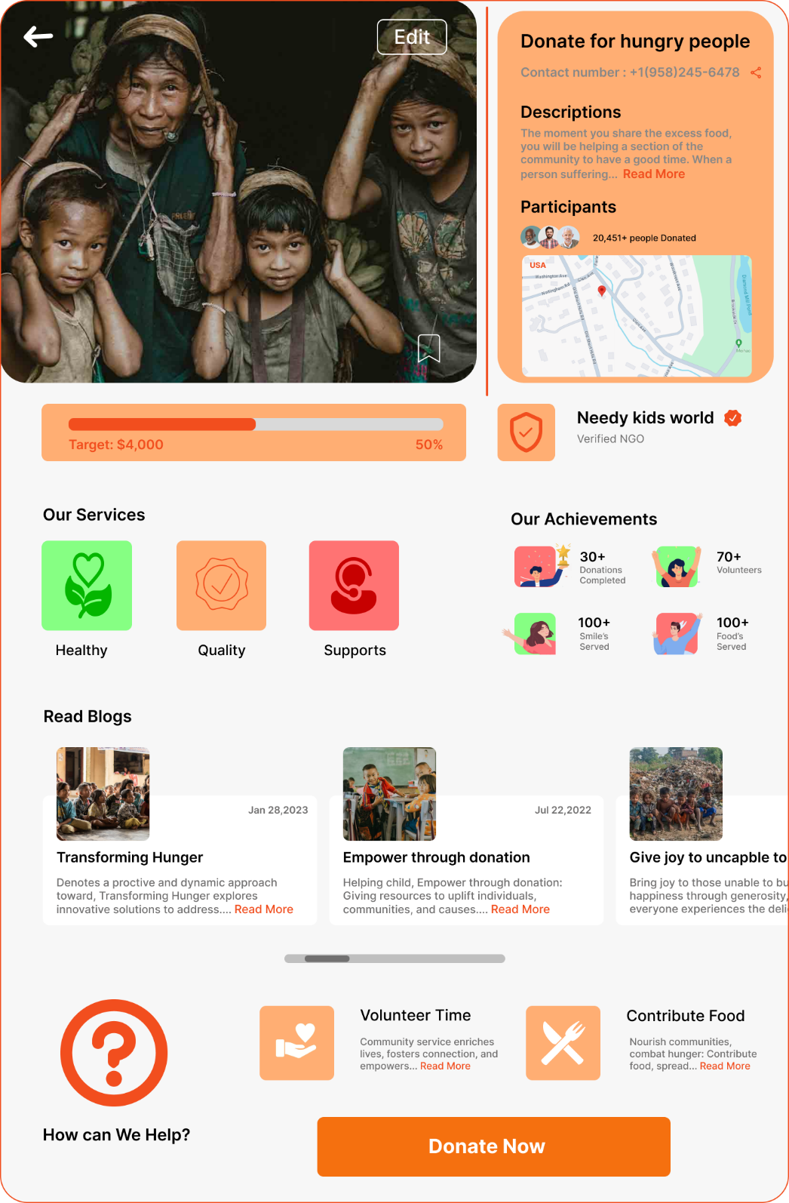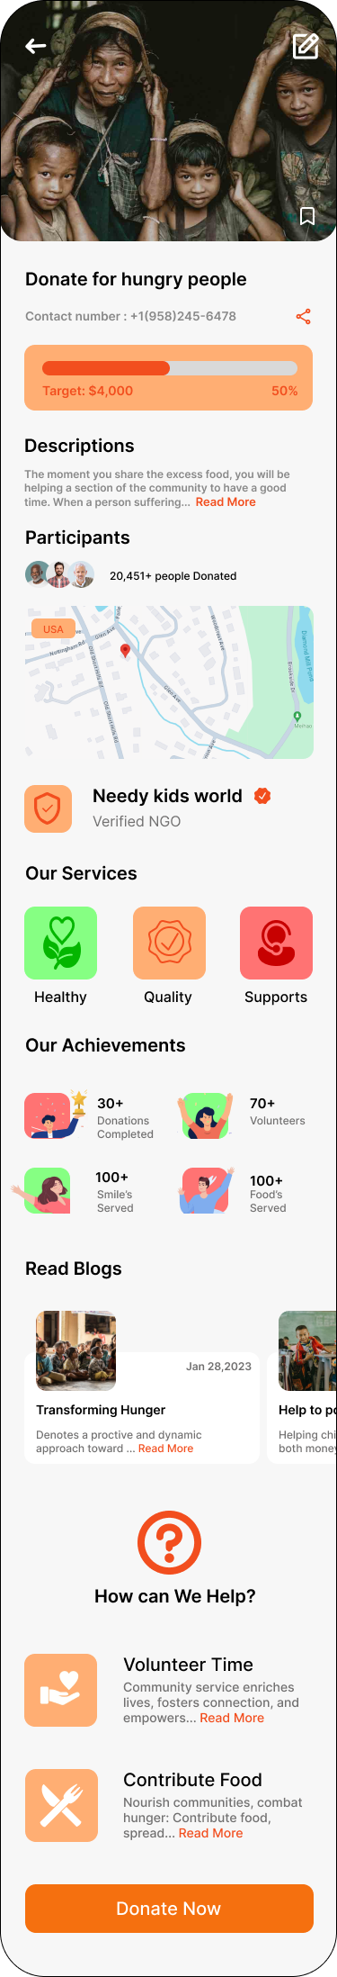View Product Information Screen.
3. 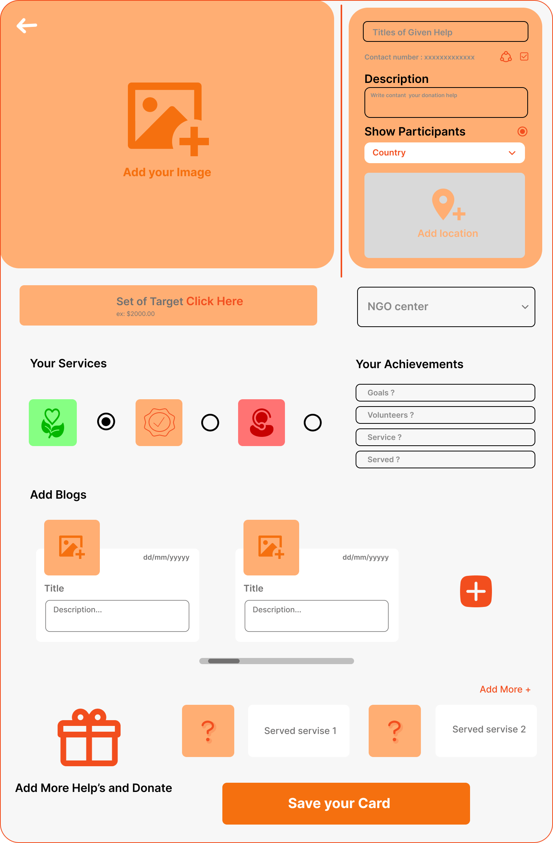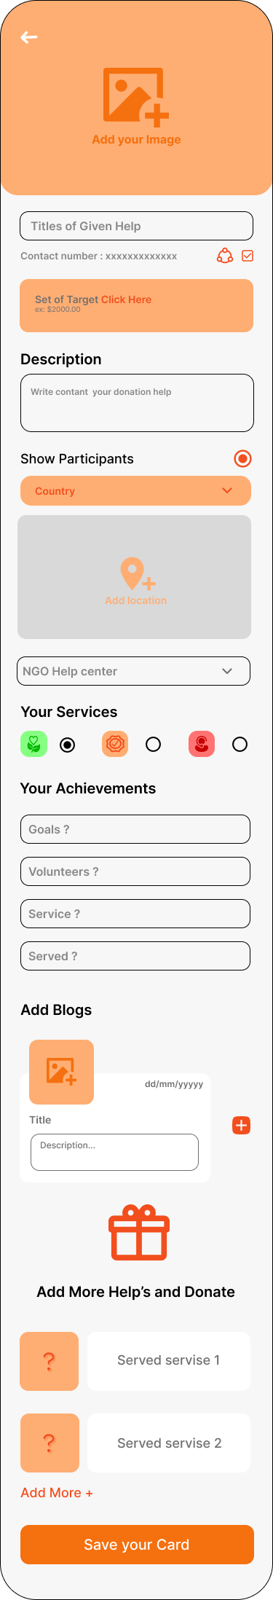Add Product Information Screen.
4. 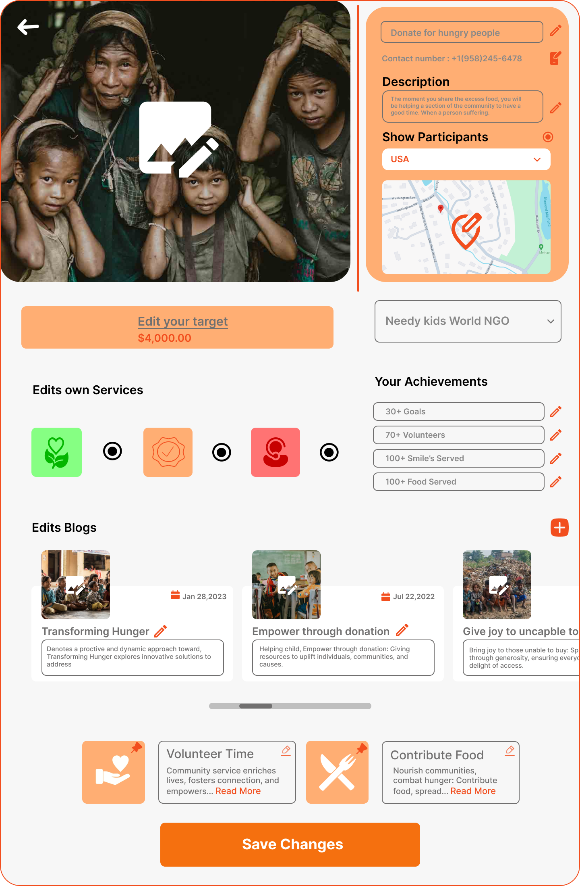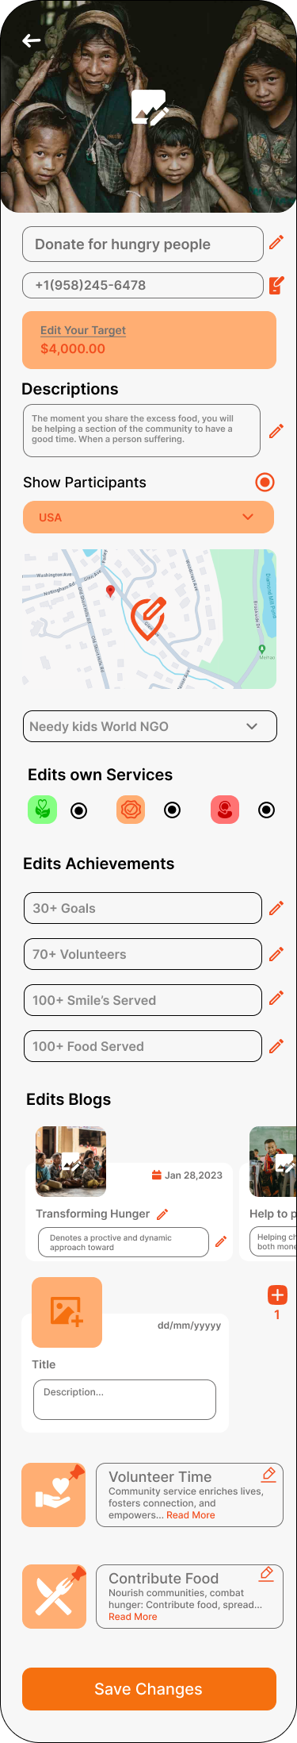Edit Product Information Screen.

# Lab Practical #09:

1. Create screens for adding a product to save.
2. 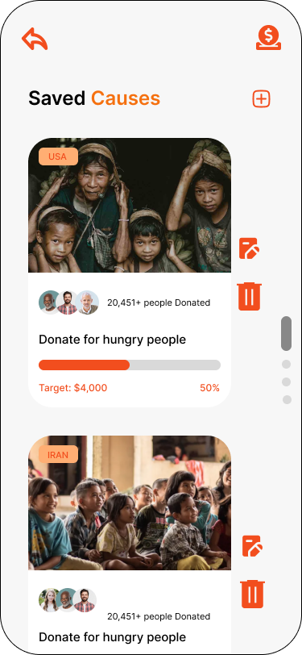Product Save Screen.

# Lab Practical #10:

1. Create screens to Share & Contact us/Chat & History cart screen.
2. Share & Contact us Screen.

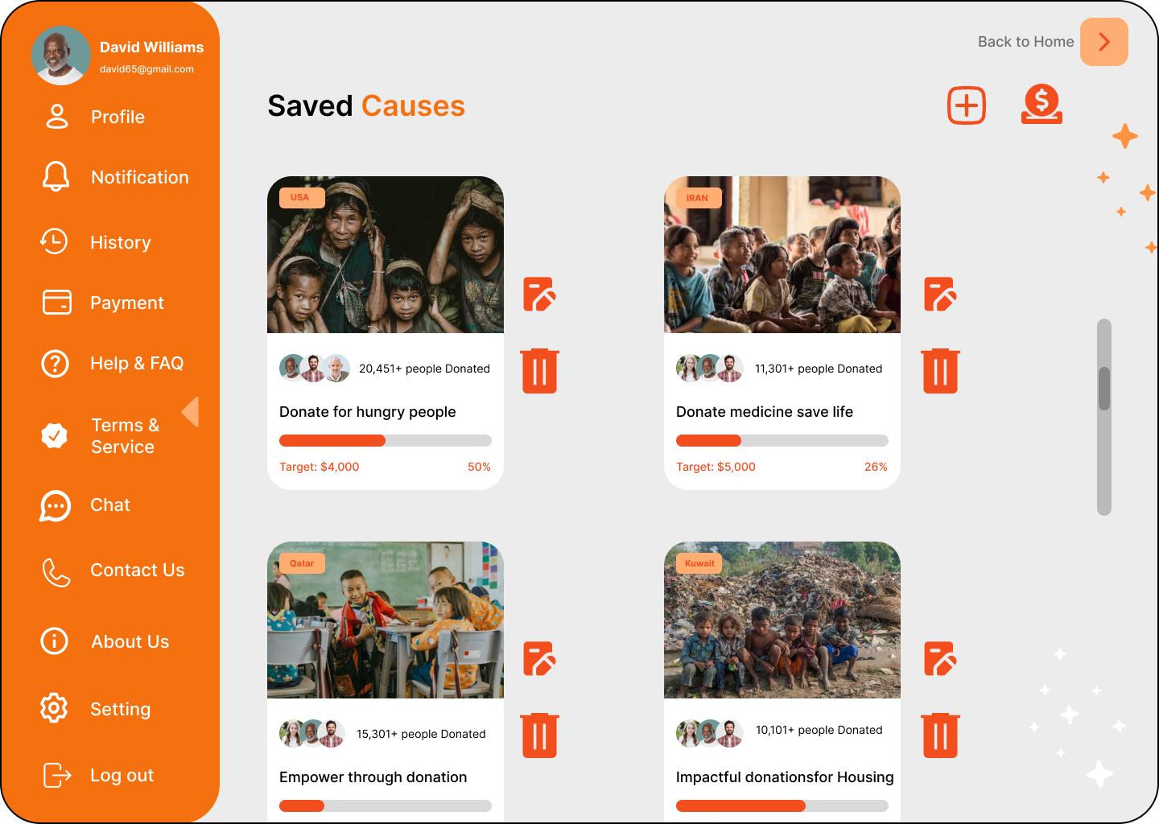

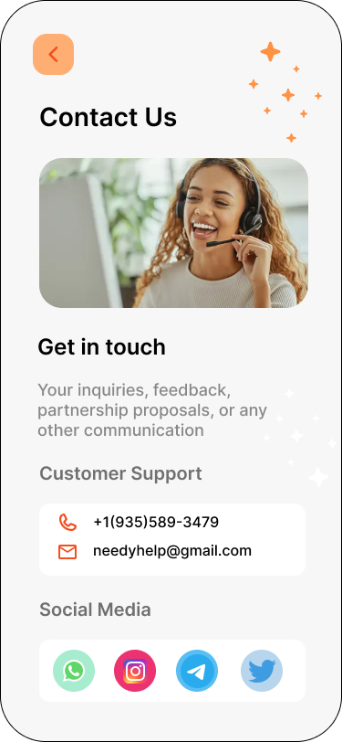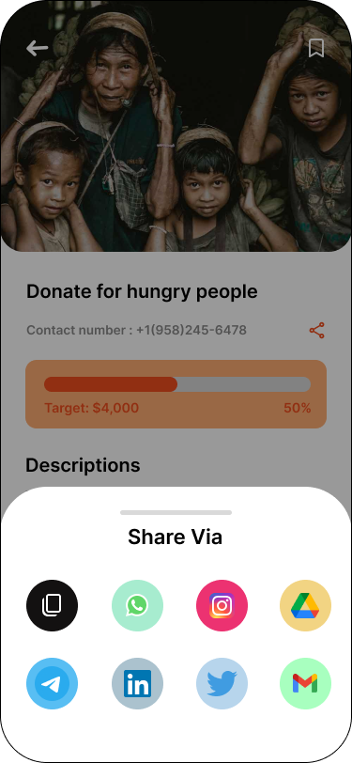

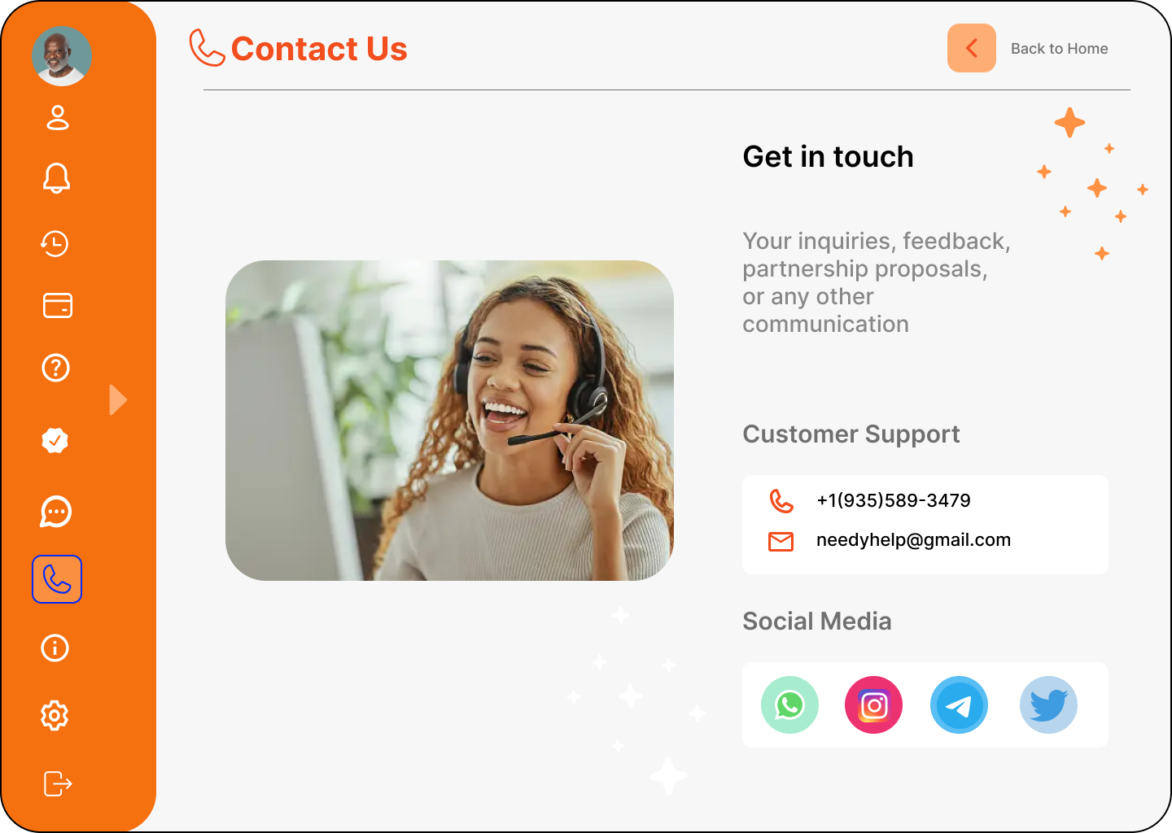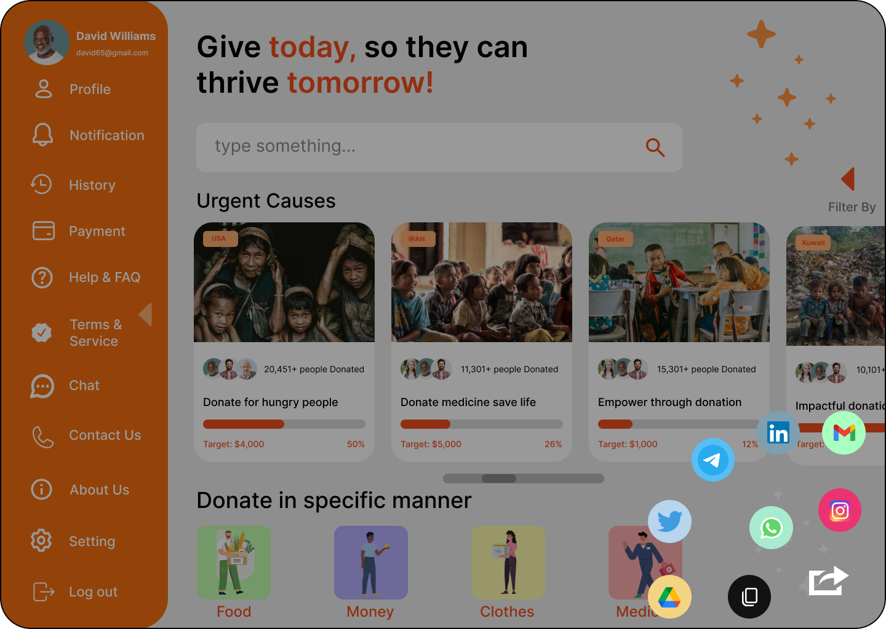

1. Chat & History Screen

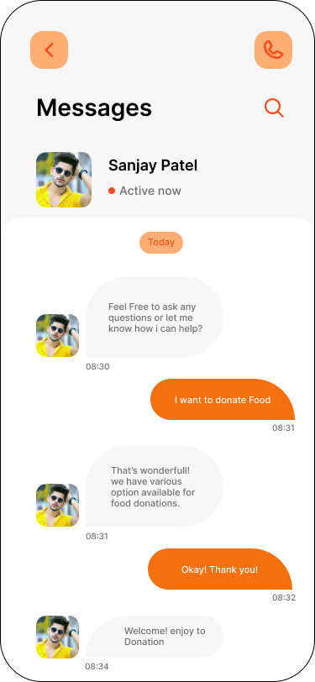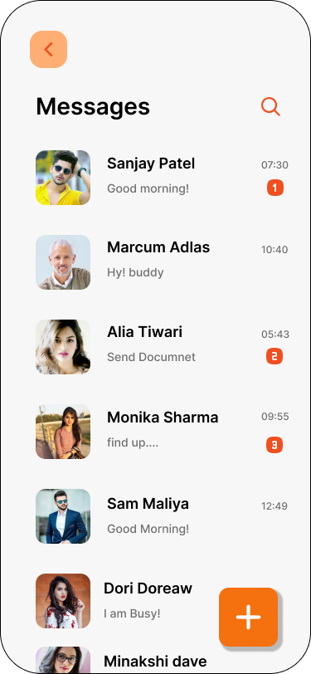

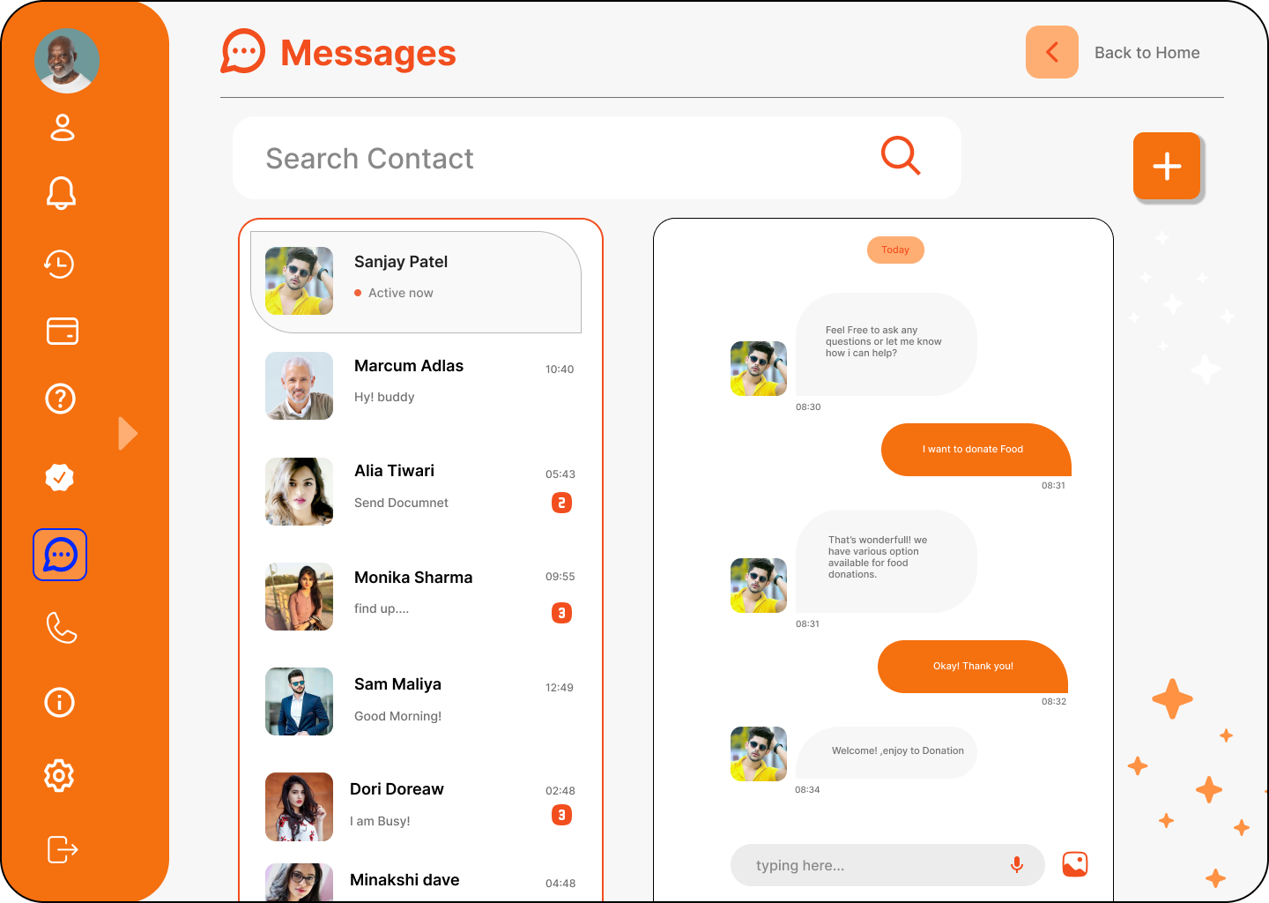

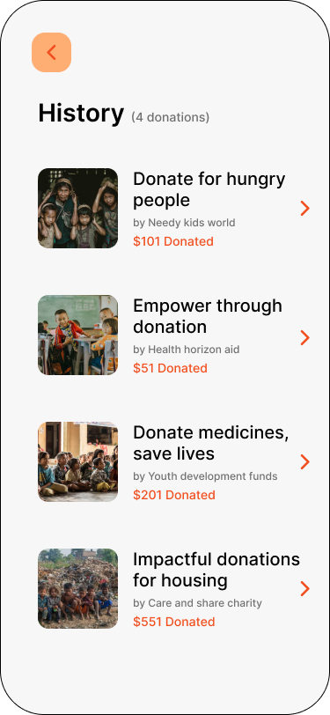

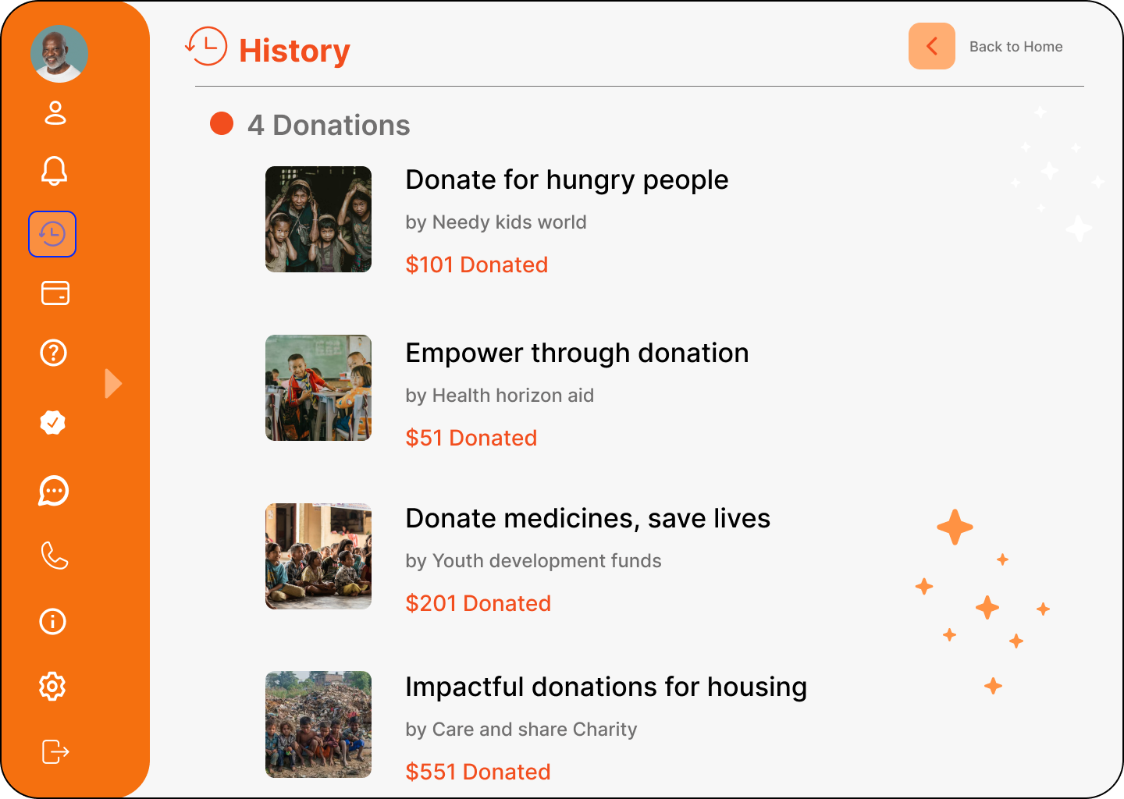

# Lab Practical #11:

1. Create screens to handle Add address & details for payment.
2. 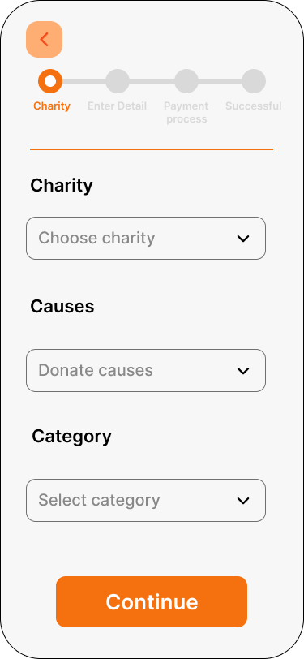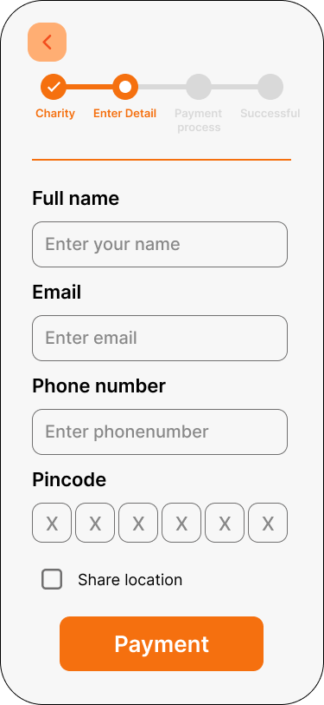Add address & details.

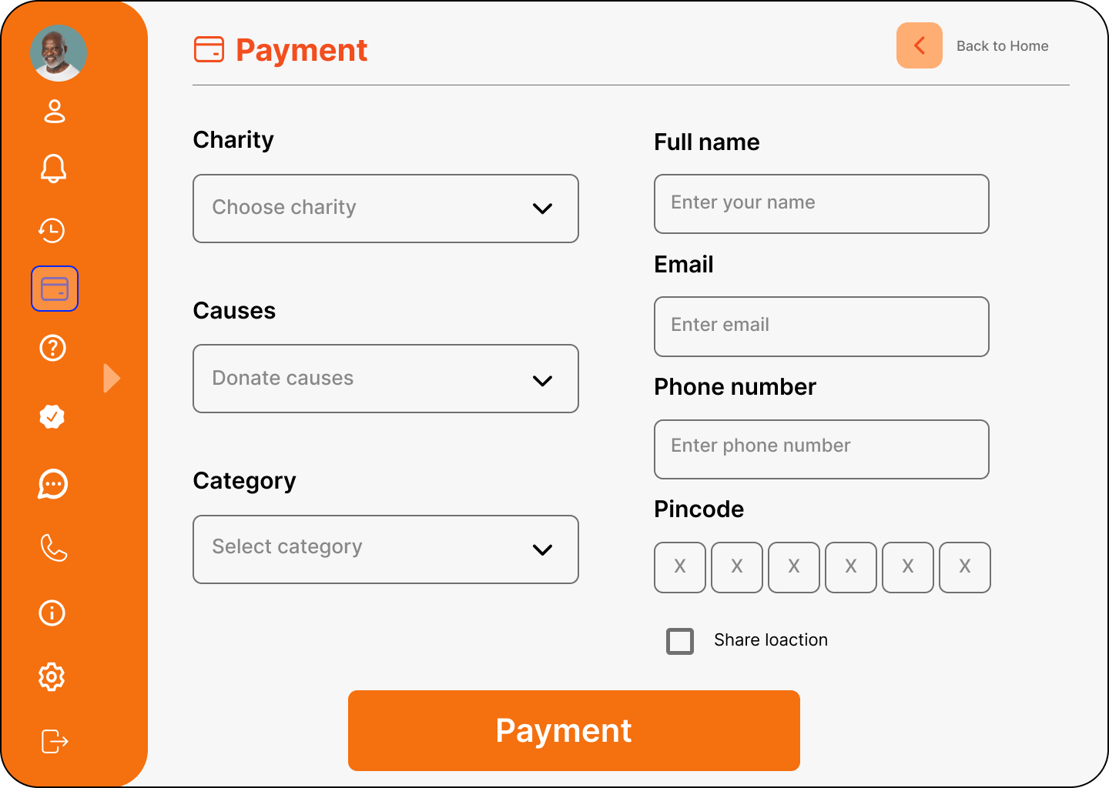

# Lab Practical #12:

1. Create screen to Payment information.
2. Payment Information Screen.

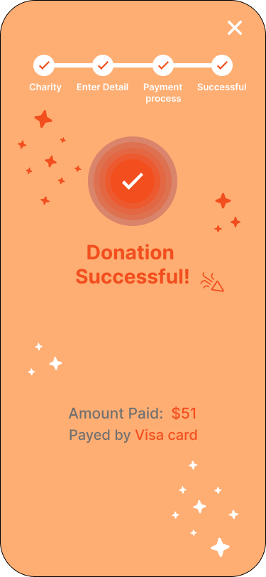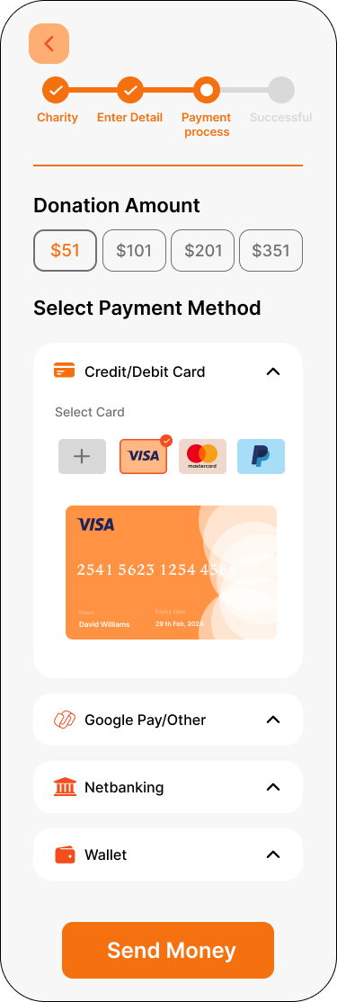

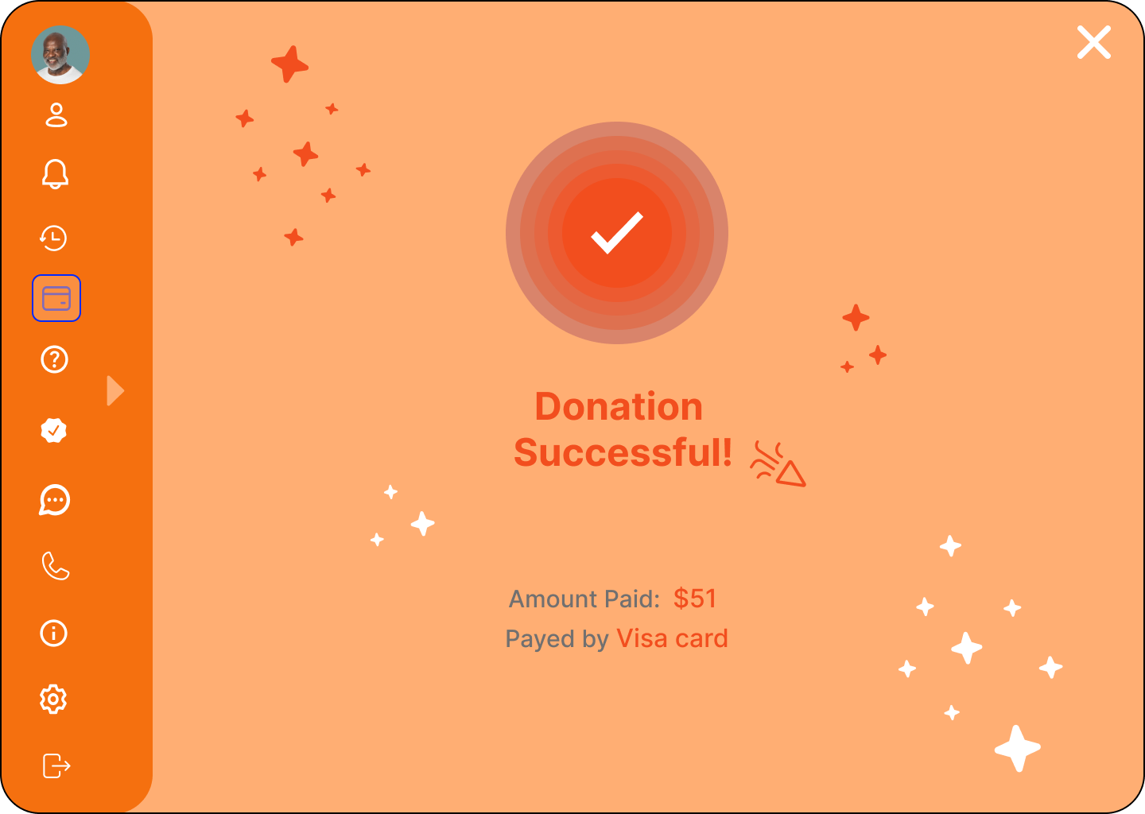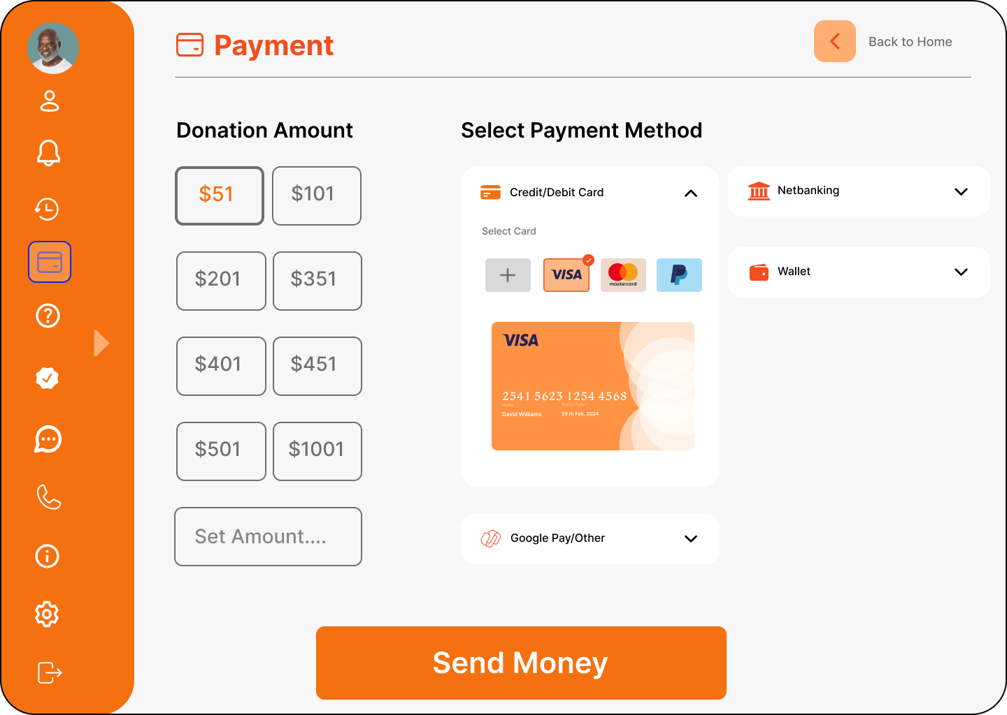

# Lab Practical #13:

1. Create screen to Notification & Logout screen.
2. notification & logout screen.

